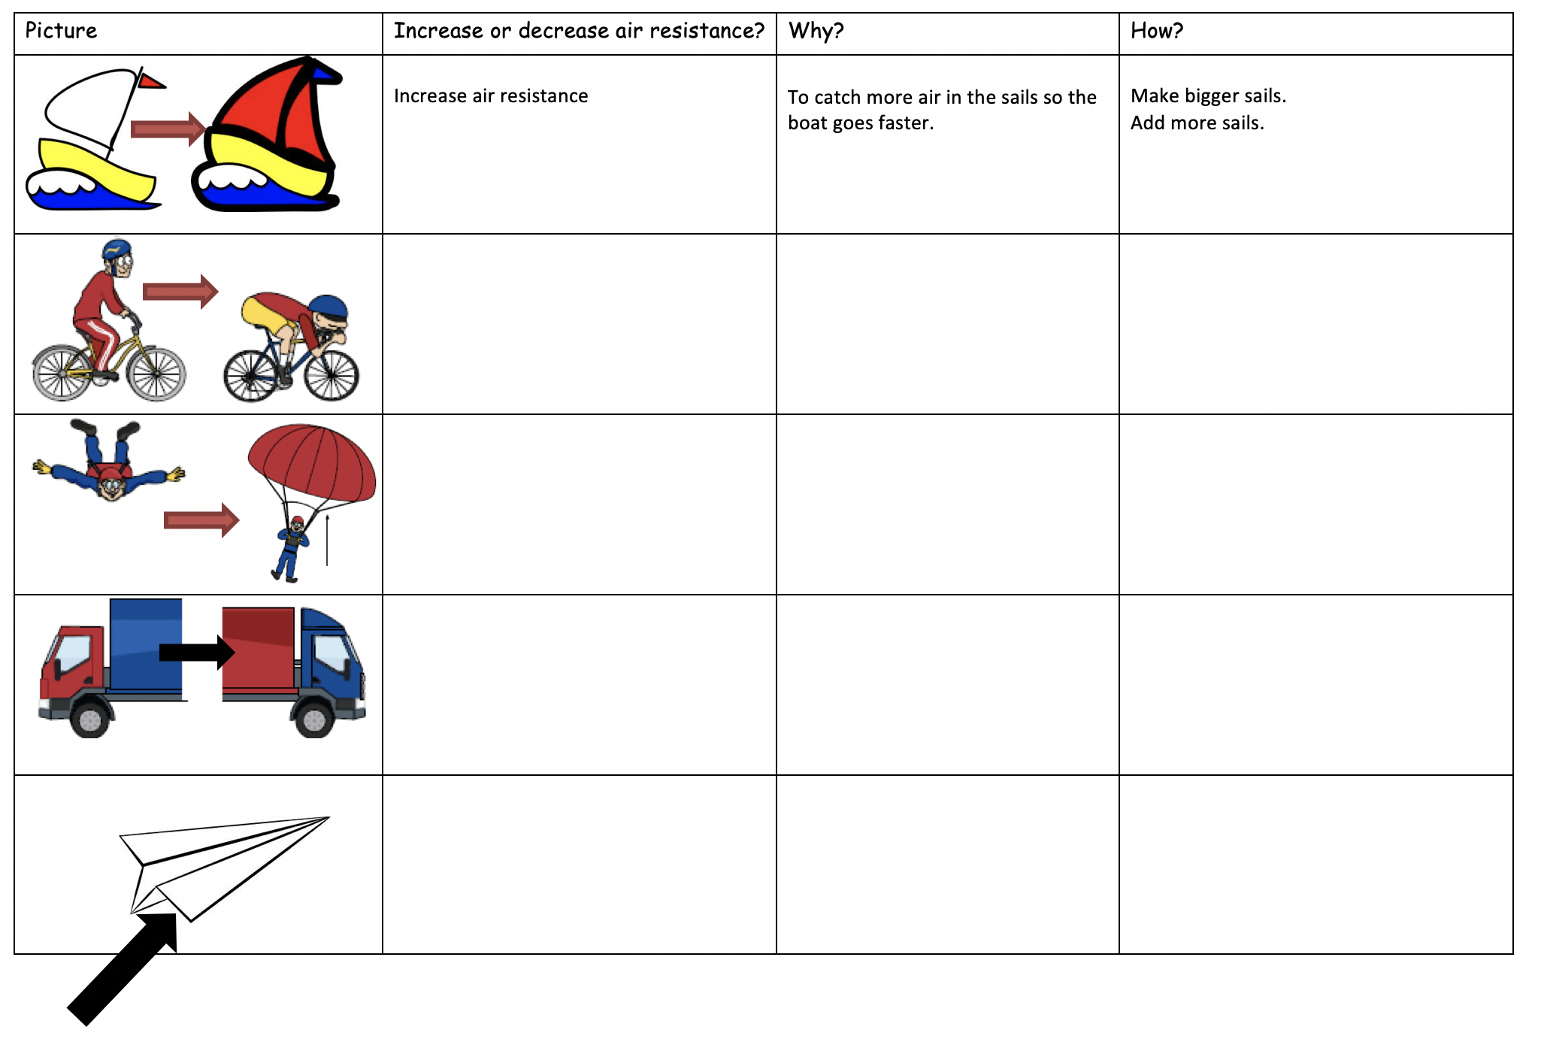

Look at the pictures: what is happening? Is air resistance increasing or decreasing?