Year 6 Art week: 15/6/20

Task One: This week I would like you to create a Giacometti style statue in tin foil. You will need to keep your tin foil statue for next week’s activity.

Here are statues by the artist Giacometti:
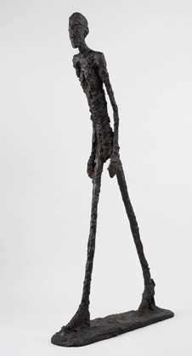
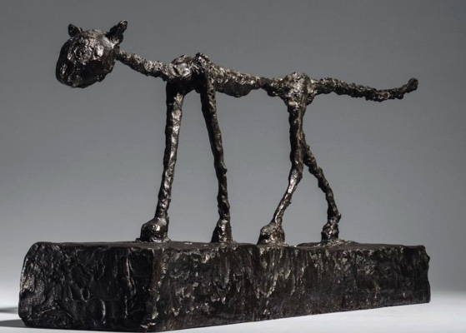

Below is how you make him/her and also how to make a cat/dog if you feel inspired, but you will need a human for next week. Don’t forget to show me your creations
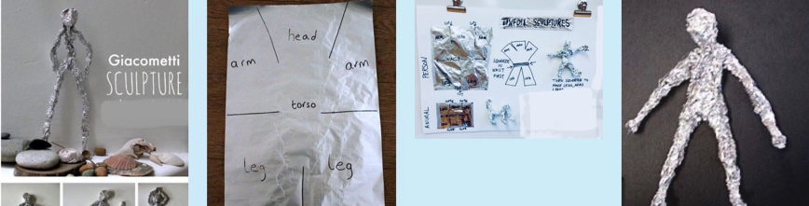

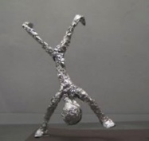

Task Two: Create an artist page with examples of his work and a short biography about his life.

