The Boy at the Back of the Class Chapters 9 - 12
Year 5 Tuesday Lesson

Using the information in Chapter 9, complete the following activity about Ahmet. On the inside of the person, write down his feelings that we see/think he will be experiencing. On the outside, record any questions, you might want to ask him.
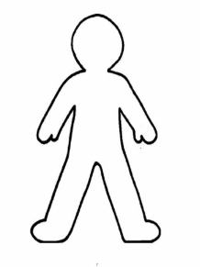

Complete the table below about his family

Family Member | Information/Facts learnt

