The Boy at the Back of the Class Chapters 5 - 8
Year 5 Tuesday Lesson

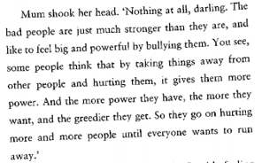

- Using the above extract from the book to help you, create a spider diagram of words and ideas linked to the word ‘POWER’ (use a thesaurus and/or dictionary to help you)

- Now answer these questions,

How does the idea of power link to the refugee experience?

Is power the same as greed?

