Wednesday 24th February

RE - To know why Shrove Tuesday and Ash Wednesday are important days for Christians
Look at the power points and then complete the passage using the words in the box below to help you. You can copy the passage into your home learning book or print and stick in. Afterwards you could draw a picture of your perfect pancake with your favourite toppings!

Pancake day is also called _____________________________________________.

This is the day ______________________ the start of _______________________.

Ash ______________________________ is the _____________________ day of Lent.

Lent lasts for _______days and nights before Christians celebrate__________________.

Lent recalls when __________________________ went to the desert for 40 days and 40 nights.

On Shrove Tuesday people tried to use all of their rich food before fasting in Lent.

This included _______________________, _____________________________

and _____________________ which make yummy ___________________________.

On Ash Wednesday Christians go to ______________________and have an ash

____________________ drawn on their forehead.

Christians pray and give thanks to ___________________at this time.
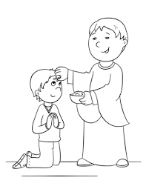

milk | God | church | Wednesday | Lent
first | Shrove Tuesday | 40 | eggs | Easter
Jesus | cross | flour | before | pancakes

Here is a picture of my perfect pancake with all my favourite toppings!!

