**Music project from Mrs Eadie**



**Hello Year 5**

I hope you are all keeping well and enjoying learning from home. It is quite hard I should imagine to do work when the sun is shining and you just want to get outside! I think that it is a great idea to do a bit of work in the morning when it’s a bit cold then get out in the afternoon when it warms up a bit in the sunshine and fresh air.

For the next few weeks we will be researching the life and works of the French composer Camille Saint-Saens (pronounced ‘San-Sohn(ce)’. We will start by revisiting one of his most well known suite ‘**The Carnival of the Animals’** .It was written in 1886 as a musical joke using the instruments of the orchestra to depict various animals and has become a classic way to introduce people to the orchestra. After its first performance Saint-Saens requested it not to be performed again- with the exception of ‘**The Swan’** (beautiful piece). There are many different versions on Youtube but this is my favourite. <https://youtu.be/k2RPKMJmSp0> The pictures depicting the different sections transport us to another place and I just love it – I hope you do too!

The whole work only takes about 25 minutes to listen to but I wouldn’t expect you to do it all in one go. Sometimes it is better to do a little and often.

Attached is a sheet with questions pertaining to each movement in the piece. Just do what you can when you can.

Try to listen in a quiet place, think about what you can hear, what pictures and colours you can see when you’re listening.

I know you have done some work previously on this work so let’s see how much you can remember!

Good Luck,

**From Mrs Eadie**

PS I hope you’re all doing lots of singing. Check out [www.outoftheark.co.uk](http://www.outoftheark.co.uk) for WK 2 free downloads for singing at home!

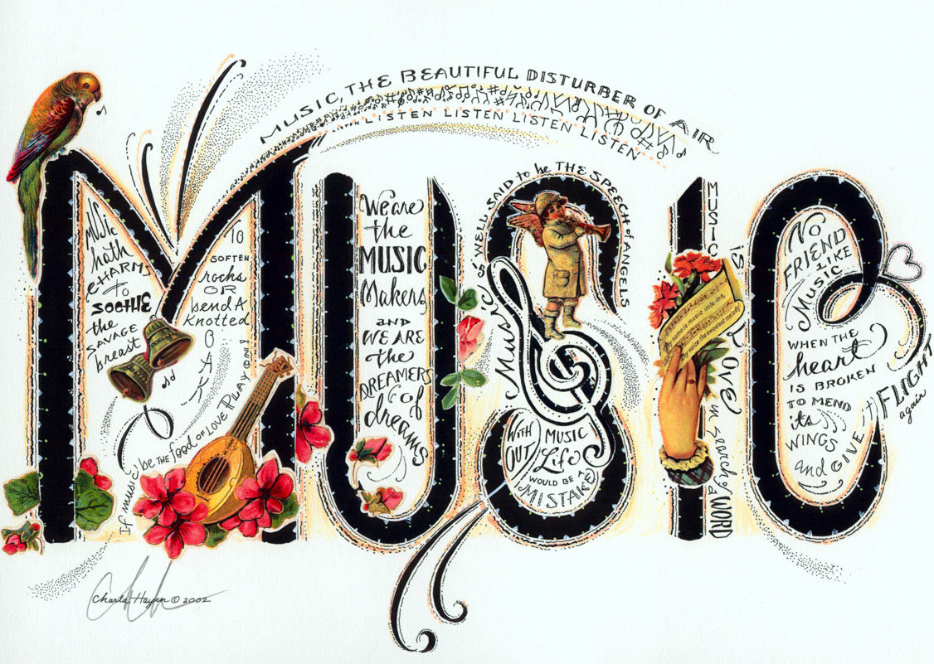



Carnival of the Animals

Composed by Saint-Saëns

## Carnival of the Animals was composed in February 1886 by a French composer called Camille Saint-Saëns. The piece is written for a symphony orchestra and has fourteen different movements that cleverly use sounds created by instruments to mimic the sounds of different animals. A performance of the whole piece lasts about twenty-five minutes!

## Look at this birds-eye view diagram of a symphony orchestra and neatly copy this into your book:

## http://theclassicalstation.org/terminology/instruments/orchestra.gif

## Now answer the following questions about the orchestra in FULL SENTENCES:

## Which SIX *different* instruments make up the string section?

## Name FOUR *different* percussion instruments.

## Which THREE *different* brass instruments are found in an orchestra?

## The flute, oboe, clarinet and bassoon make up which section?

## What role does the conductor have in an orchestra?

## MCj04241280000[1]Listen to each movement of Carnival of the Animals and answer the questions as you go along.

Movement One: **Introduction and Royal March of the Lion** *(Tracks 1 & 2)*

1. Which instrument begins the piece?
2. Are the very first notes high or low pitched?
3. Which section of the orchestra plays throughout the introduction?
4. Listen to the string section as it first plays the *March* theme. Is this melody high or low pitched?
5. What dynamic is the very last note of the Royal March of the Lion?

Movement Two: **Hens and Cockerels** *(Track 3)*

1. MCj04246860000[1]In this movement Saint-Saëns composes music that sounds like chickens pecking at grain. How does he achieve this?
2. By using long, sustained, low-pitched brass notes?
3. By using short, high pitched, repetitive string and piano sounds?
4. By using muted pizzicato strings?

2. Listen **very** carefully. There is ONE woodwind instrument that plays in this movement. Which one is it?

MCj03264880000[1]Movement Three: **Swift Animals** *(Track 4)*

1. Which instrument plays throughout this movement?
2. Do you think that the swift animals are:
3. strolling?
4. stealthily hunting their prey?
5. running?
6. going for a civilised morning jog around the block?

MCj04241340000[1]3. Explain your answer to question number 2.

Movement Four: **Tortoises** *(Track 5)*

1. Describe the dynamics at the opening of the piece.
2. The string section are playing the famous ‘Can-Can’ theme – at what tempo?
3. Why does this movement effectively portray a tortoise?

MCj04241500000[1]Movement Five: **The Elephant** *(Track 6)*

1. Apart from the piano, which other instrument is playing?
2. At what pitch is the main theme played?

Movement Six: **Kangaroos** *(Track 7)*

1. MCj03561130000[1]How does the piano create a hopping sound?
2. By pressing and holding down the piano keys firmly?
3. By using a pattern of short ascending and descending notes?
4. MCj03319160000[1]By opening up the lid of the piano so the sound resonates around the concert hall?

Movement Seven: **Aquarium** *(Track 8)*

1. What is the overall pitch of this movement?
2. Listen **very** carefully. There is ONE woodwind instrument that plays the theme in this movement. Which one is it?
3. Which instruments are NOT playing in this piece?
4. Close your eyes and imagine a dimly-lit, peaceful aquarium as you listen to this piece. How is this music effective?

MCj03189420000[1]Movement Eight: **Animals with Long Ears** *(Track 9)*

1. How does Saint-Saëns create the sound of jumping hares?

* 1. By using cellos to play low buzzing notes in an ostinato theme?
  2. By using the piano to play a drone?
  3. By using violins to play high, shrill screeches and low, buzzing notes

MCj01095050000[1]Movement Nine: **The Cuckoo in the Depths of the Woods** *(Track 10)*

1. Which woodwind instrument mimicks the call of a Cuckoo bird?
2. When something repeats over and over again without changing, what is this called?

MCj02697560000[1]Movement Ten: **The Aviary** *(Track 11)*

1. Which woodwind instrument plays a trilling tune that portrays birds flying around an aviary?
2. 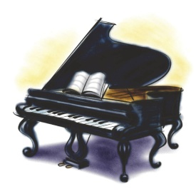What is being played in the background by the violins?
3. At what dynamic does this movement end?

Movement Eleven: **Pianists** *(Track 12)*

Here, Saint-Saëns is teasing piano players that they are also animals!

1. This music sounds like the pianists are practicing their scales. What do you think a scale is?
2. 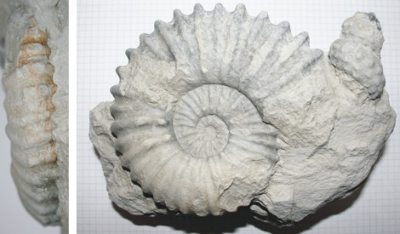What happens inbetween each scale?

Movement Twelve: **Fossils** *(Track 13)*

1. Which percussion instrument is playing the main theme?
2. xylophone
3. glockenspiel
4. timpani
5. When the strings play underneath the solo percussion instrument, what special technique are they using?
6. 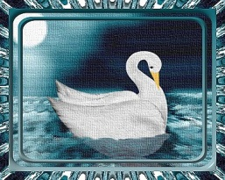Describe the tempo of this movement.
7. Why does this movement successfully portray fossiles?

Movement Thirteen: **The Swan** *(Track 14)*

1. This is the most famous movement of the whole suite. Which stringed instrument performs the elegant melody of the Swan?
2. Which instrument provides the accompaniment?

Movement Fourteen: **The Finale** *(Track 15)*

1. This movement opens in a similar way to one of the other movements. Which one?
2. Many of the previous movements are quoted here. Name as many as you can!