YEAR 6 | Autumn 1 | Autumn 2
English | 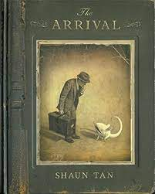  Writing to Entertain (The Arrival)  Setting descriptions  Character descriptions  Writing to Inform (The Arrival)  Persuasive letter | 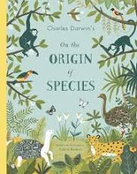  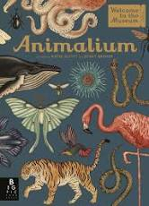  Writing to Entertain (The Origin of Species)  Diary Entries  Writing to inform (The Origin of Species/Animalium)  Biography  Non-chronological report
Grammar and punctuation | Word classes (nouns, verbs, adverbs, adjectives, determiners)  Modal verbs  Converting nouns into verbs and vice versa  Synonyms and antonyms  Relative clauses | Statements, questions, commands and explanations  Co-ordinating and subordinating conjunctions  Adverbial phrases  Identifying clauses  Prefixes and suffixes
Spelling | Words from the Statutory Word List  Words ending in ‘ible’ and ‘able’  ‘ie’ and ‘ei’ words  Words with silent letters  Homophones  Words ending in ‘ant’ and ‘ent’  Words ending in ‘ance’ and ‘ence’ | Words from the Statutory Word List  Words ending in ‘cial’ and ‘tial’  Words ending in ‘cious’ or ‘tious’  Words ending in ‘tion’, ‘sion’ or ‘cian’  Adding suffixes
Guided Reading | Boy in the Tower | Boy in the Tower
Maths | Number - Place Value  Number – Addition, Subtraction, Multiplication and Division | Number – Fractions  Geometry: Position and direction
Science | Animals and their habitats | Evolution and inheritance
Geography | Where are there so many rainforests in South America?
History |  | What did the Ancient Maya do for us?
Computing (switched on computing) | E-safety | Programming: Kodu
RE | Hinduism | Hinduism
PSHE/P4C | Think Positive  Go Global/P$C | Diverse Britain  Go Global/P4C
Art | Art and Design Skills | Mayan Art
Music | Wider Opportunities | Wider Opportunities
PE | Invasion Games | Gymnastics
DT |  | Textiles

