YEAR 6 | Spring 1
English | 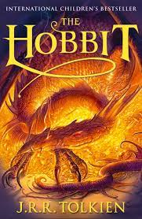  Writing to Entertain (The Hobbit)  Describing a character through the setting  Using dialogue to convey character  Traditional tales
Grammar and punctuation | Semi-colons for clauses  Semi-colons and colons in lists  Using inverted commas  Colons for clauses
Spelling | Words from the Statutory Word List  Phoneme: e (Grapheme: ee, e , ea , y , ey)  Phoneme: I (Grapheme: i, y)  Phoneme: I (Grapheme: ai , ie)  Phoneme: I (Grapheme: eigh , y-e, ais , i)  Phoneme: o (Grapheme: o, a, au, ou, e, eau, ow)
Guided Reading | SATs reading revision
Maths | Number – Decimals  Number – Percentages  Number - Algebra
Science | Light
Geography
History | Why was there a mill in Mobberley?
Computing (switched on computing) | E-safety/ Big Data
RE | Christianity
PSHE/P4C | VIPs  Go Global/P$C
Art | Make your voice heard
Music | Wider Opportunities
PE | Dance/gymnastics
DT

