Thursday 25th February
RE – To understand why pancakes are made on Shrove Tuesday (Pancake Day) Look at the Shrove Tuesday power point and film clip then fill in the words. You can either write the sentences into your home learning book or print and stick it in. Afterwards draw a picture of your perfect pancake with your favourite toppings!
Pancake Day is called Shrove Tuesday. This year Shrove Tuesday was on 16th February.

Pancake Day is the day before the start of Lent.The first day of Lent is called Ash Wednesday.
Pancakes are made from __________________________________.
People used to try and use up all the foods in their house that they are giving up for Lent.

This Lent I will try and give up _______________________________________.

In my perfect pancake I would put_______________________________________________
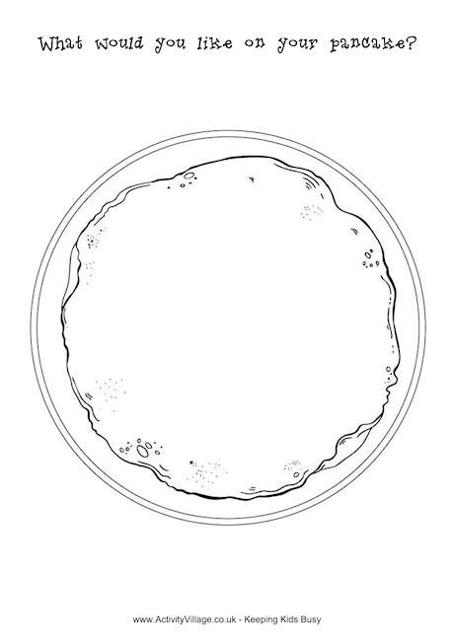
Here is my perfect pancake – yum yum!

