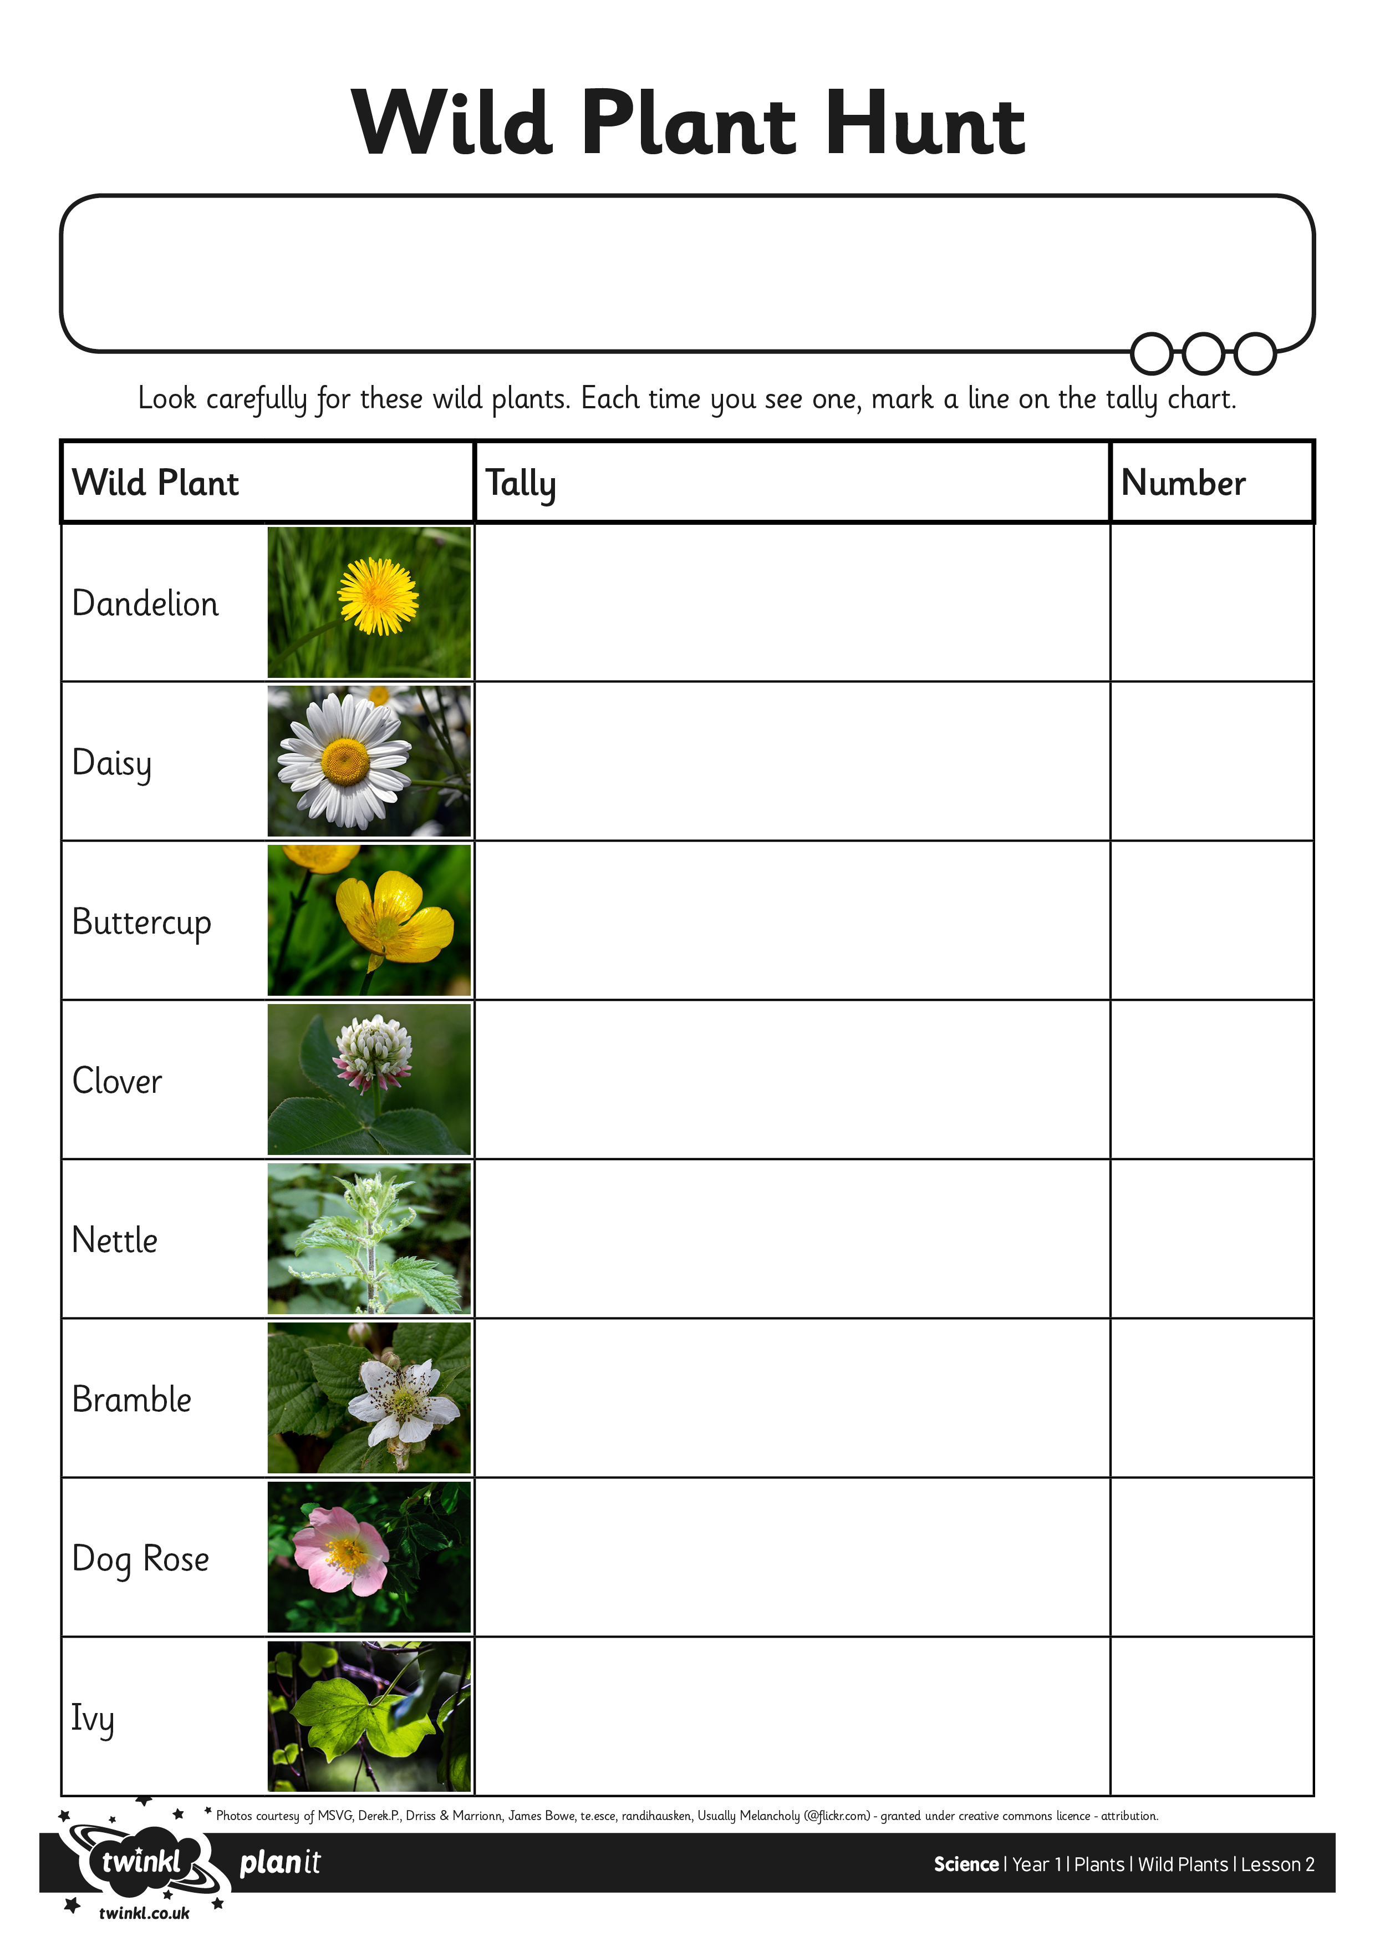
I can identify and name wild plants.
Let’s go on a hunt for some wild plants!

Every time you see one of the wild plants, draw a line in the tally chart.
Remember that line number 5 goes across, like a gate.

= 6

