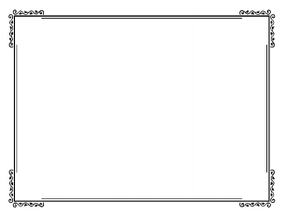

When I am a grown up, I will look back on when I was my age now and think… ____________________________________________________________________________________________________________________________________________

^ Me doing my future job! ^

My job will be ____________________________________________________________________________________

I would like to do this job because ________________________________________________________________________________________________________________

I will have ___________________

____________________________

I will not have ________________

____________________________

I will eat ­_____________________ ____________________________

I will not eat _________________

____________________________

My favourite thing to do will be ____________________________________________________________________________________

This is what I will look like

30