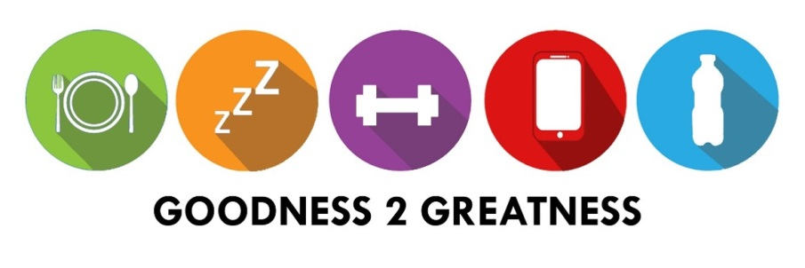
MOBBERLEY TO TOKYO: 8238 miles

Name………………………………… Class ………………. Month ………………………

 | MON | TUES | WEDS | THURS | FRI | SAT | SUN
Exercise I did today: (30 minutes)
Bonus:
Meal I cooked this week
 | MON | TUES | WEDS | THURS | FRI | SAT | SUN
Exercise I did today: (30 minutes)
Bonus:
Meal I cooked this week

