**15/7/20**

**SC: I can calculate the volume of cuboids**

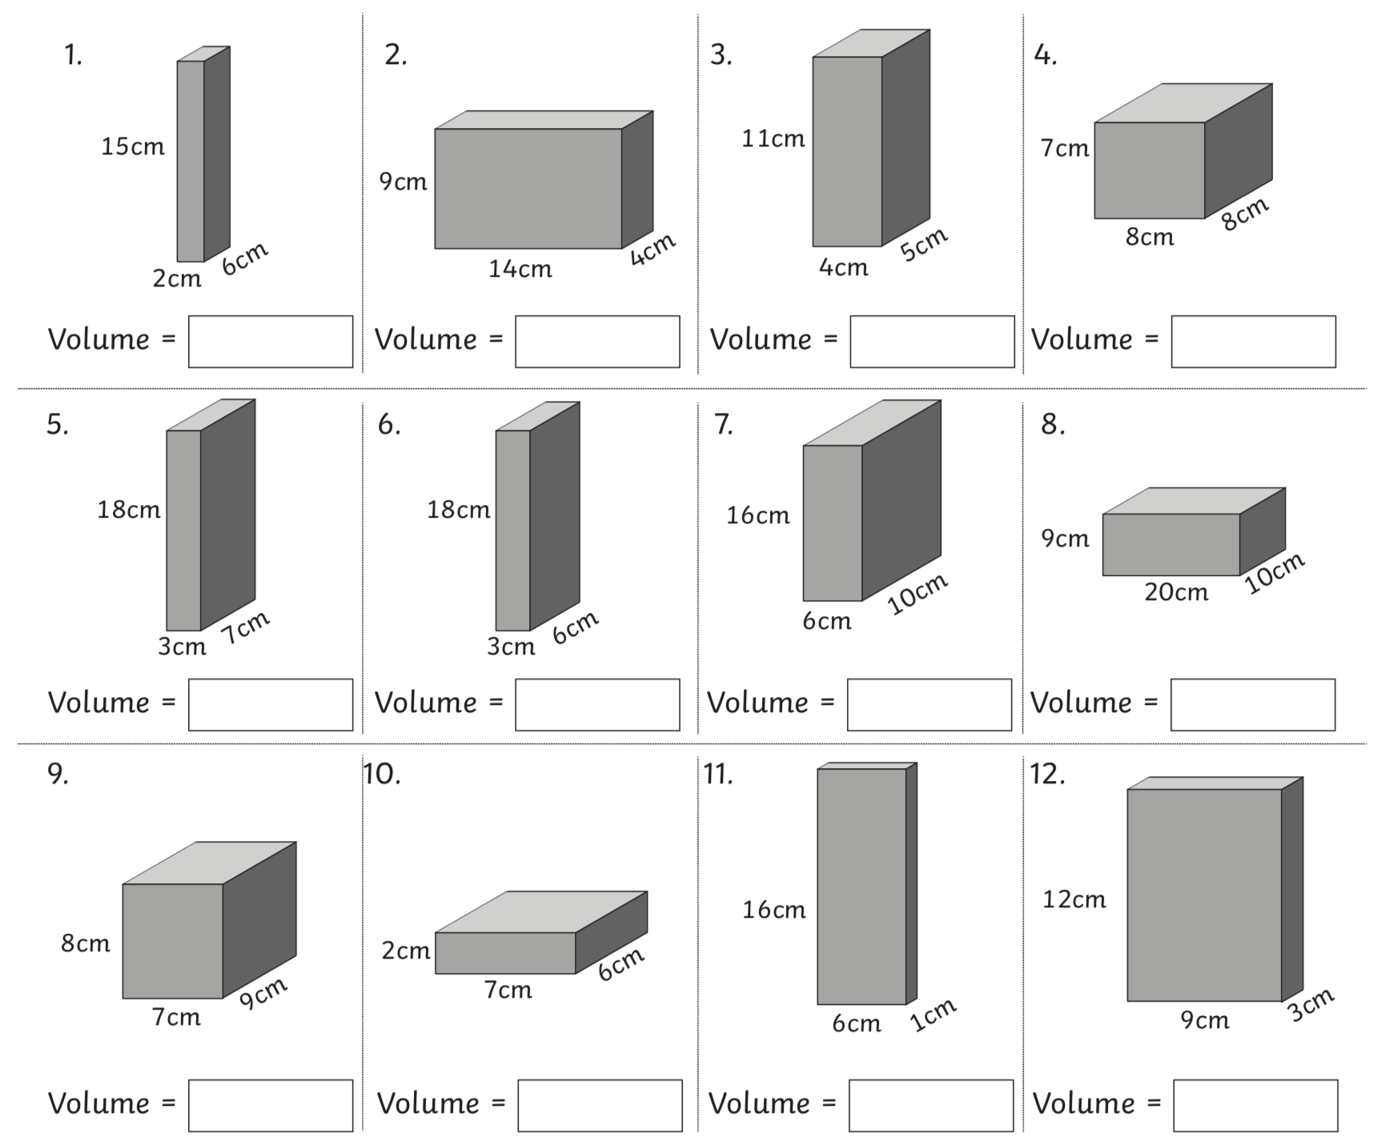

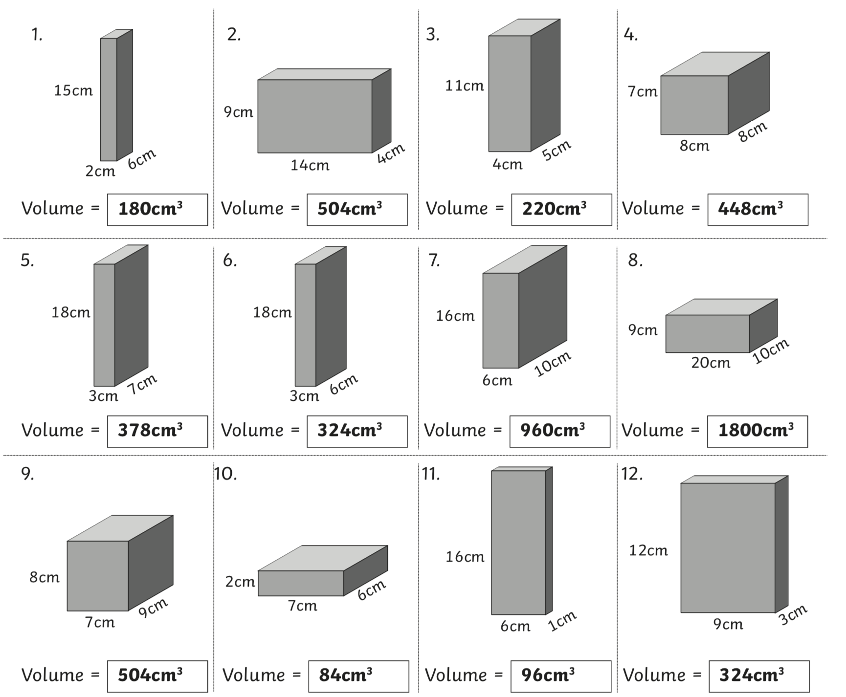**ANSWERS**