**Extra challenge**

**Relative Clause**

Tom Arthur, who has written 20 books, has said that he would like children to be excited when they read books.

**Brackets**

We could only find one example of an author who included a girl as the main character (Tom Arthur).

**Modal Verbs**

You cannot

Would it not be better if

Couldn’t you…

Should we not..

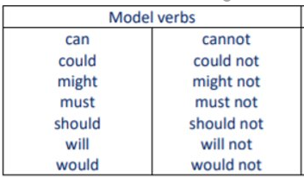

**Contrasting conjunctions**

However

Although

Despite the fact that

Even though

**Adverb starters**

Unfortunately, Unbelievably, Disappointingly, Understandably, Inevitably, Ultimately, Lastly, Firstly,

**Key words list**

Informed

Vehemently

Consequences

Detrimental effect

Inevitably,

Deficit

Catastrophic

Prioritise

Ultimately,