CV

CV

CV

CV

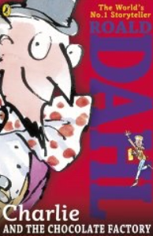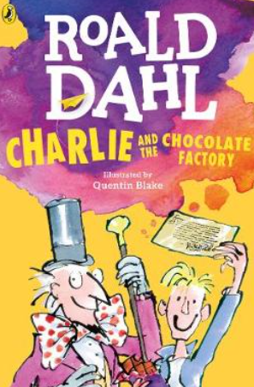

Charlie and the Chocolate Factory

Story Map

What’s happened so far?