6 Figure Grid Reference activity 5
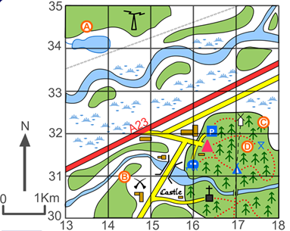

Key
= Church
= Parking
= Coal Mine
= Caravan site
= Windmill

Q1 Give the 6 figure grid reference for

Coal Mine : : _____________________
Parking: _____________________
Castle : ________________________
Church : _________________________
Caravan site: ______________________

Q2 What is at the following grid reference:

164304 = __________________________
143310 = __________________________
172318 = __________________________
171323 = __________________________

