Monday 18th January 2021
Shared Reading

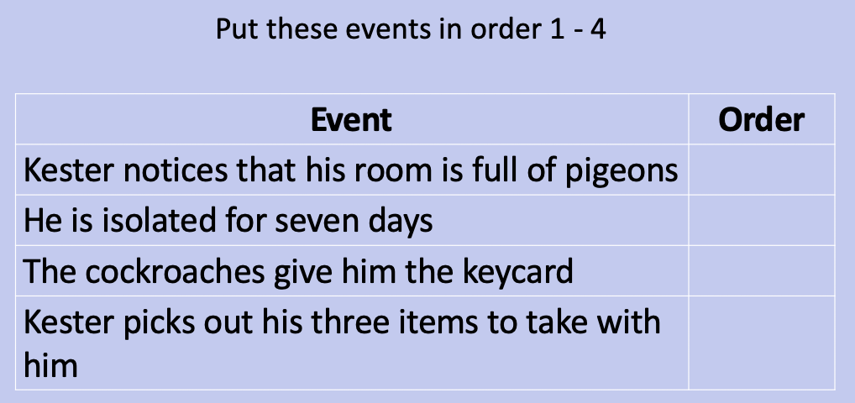
Order these events:
- What flavour formula is shoved through the hatch in his bedroom door when he is isolating?

- What wakes Kester up from his dream?

- What does Kester want to do when he first sees the pigeons?

- What were the last words Kester spoke to his Mum?

- What kind of noise do the cockroaches make?

- What does Kester call the cockroach leader?

