Seahorse: The Shyest Fish in the Sea- Planning 29th June – 3rd July
You will find planning for the next two weeks as well as resource sheets in this document. Please view the photo story and youtube video reading.
Monday 29th June | Watch the seahorse clip on Amazing Animals  https://www.youtube.com/watch?v=XqP0xqbnAMU  Use the picture and label resources to label the parts of a seahorse.
Tuesday 30th June | Watch the video clip – I’m a seahorse  https://www.youtube.com/watch?v=lOp4bXreGmI  Make notes about seahorses and sort your notes in to categories (diet, habitat, appearance, babies, did you know?).
Wednesday 1st July | Research your own questions about seahorses using books and the internet – can you add to your fact categories from yesterday?
Thursday 2nd July | Make your own 3D seahorse! – paper craft template link here
Friday 3rd July | Research write up. Write an information text about seahorses. Make sure you include headings, subheading and facts.  Template below.

Monday 29th June
SC: I can label the parts of a seahorse.

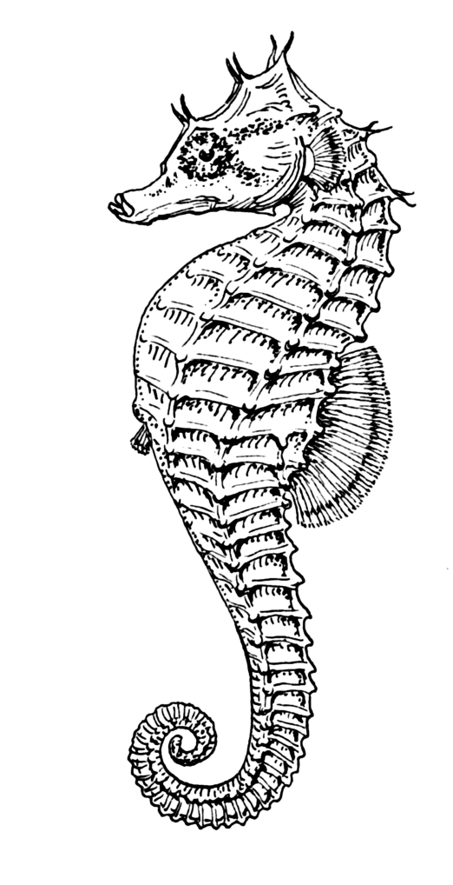
Eye – The eyes do not move together. Each eye moves on its own. | Pouch – The male seahorse keeps the eggs in here to be safe until they hatch. | Tail – Seahorses use their tails to stay anchored in place.
Coronet – Each seahorse’s coronet is different. | Dorsal fin – This moves the seahorse forward. | Snout – Seahorses do not have teeth, they suck up their food.

Tuesday 30th June
SC: I can make notes about seahorses.

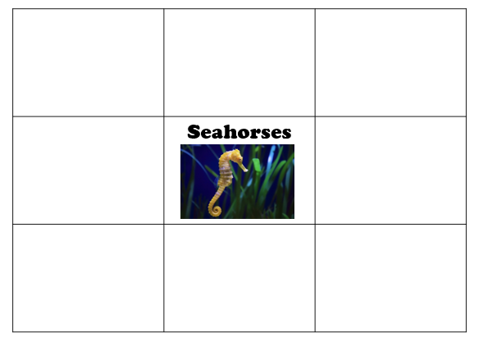

Wednesday 1st July
SC: I can research my own information using books and the internet.
Add to your notes from yesterday and sort your information in to categories.

Question 1:____________________________________________________________
Answer: ______________________________________________________________

Question 2:____________________________________________________________
Answer: ______________________________________________________________

Question 3:____________________________________________________________
Answer: ______________________________________________________________

Question 4:____________________________________________________________
Answer: ______________________________________________________________

Question 5:____________________________________________________________
Answer: ______________________________________________________________

Friday 3rd July
SC: I can write an information text about seahorses.

Seahorses

Diet
________________________________________________________________________________
________________________________________________________________________________

Habitat
________________________________________________________________________________
________________________________________________________________________________

Appearance
________________________________________________________________________________
________________________________________________________________________________

Babies
________________________________________________________________________________
________________________________________________________________________________

Did you know?
________________________________________________________________________________
________________________________________________________________________________

