Scrumdiddlyumptious Topic Home Learning
Choose as many tasks as you like- how many points can you get?! Try your very best with every task you choose.
5 Points | 10 Points | 15 Points
Create a healthy menu.  (Present it beautifully!) | Complete a food diary for a week. | 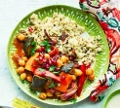  Choose a healthy meal to cook and either bring it into school for us to taste or take photos of it.
Write an imaginary recipe for your  dream pudding! | Can you find any famous songs that are about food?  Write down any songs that you can find once you have listened to them.  Which is your favourite? | Write a story about an animal which eats other animals. This could be done as a comic strip or a mini book. Be creative!
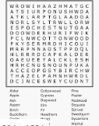  Create a word search using the names of the bones/ joints in the human body. | Collect food packaging (you can look at packaging online if it’s tricky to get to the shops) which show the sugar and/or fat content of foods.  Sort them out into healthy/unhealthy foods. You could do this in the form of a Venn diagram.  Present in a way that is eye catching and exciting.  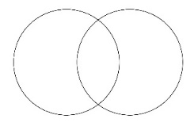  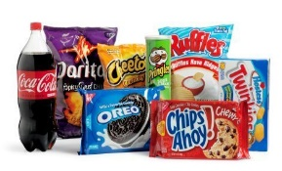 | Create a board game/card game encouraging people to eat healthily and look after their bodies.  Think about games like Monopoly/ Uno for inspiration. It can be as inventive and creative as you like!  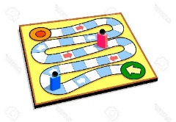  Can you play it with your family at home?
What does Fair Trade mean?  Create a fact file or a leaflet explaining why people should buy Fair Trade food? | What are your favourite foods?  Use a world map to plot where each of your favourite foods are from.  Don’t forget to create a key! | Create a healthy food plate for somebody with a balanced diet and illustrate.  What are the food types?

