Science Activity - Week beginning 30th March
In science lessons at school, we have been finding out about the life cycle of plants.
This week I would like you to find out about the different ways that plants disperse their seeds.
First, watch this video
https://www.bbc.co.uk/bitesize/clips/znvfb9q
Have a look on this page for more details
http://www.mbgnet.net/bioplants/seed.html
- Create an information poster detailing how different plants disperse their seeds.
- Once you have found out lots of information about seed dispersal I would like to set you a challenge (something I will be taking part in as well!). Using the template for a seed below I would like you to see how far you can get your seed to travel. Can you make it fly across the living room or out in the garden? Can your seed travel through your house? You can use anything you want to get your seed to move except for your hands (MAKE SURE YOU ASK AN ADULT FIRST). You could use wind power, water power or another method which is a complete invention of your own! I look forward to seeing what you create!
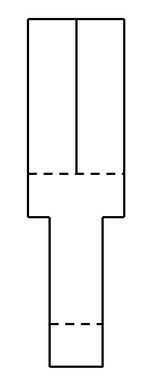
Look on the website for the link where I show you how to make one if you are not sure.

