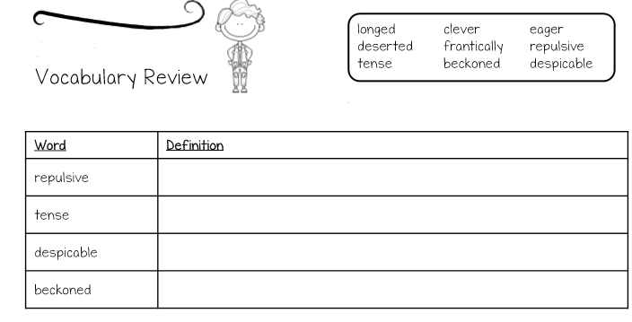

Use a dictionary (it can be an online dictionary too!) to find out what the words below mean. Write the definition in the box…

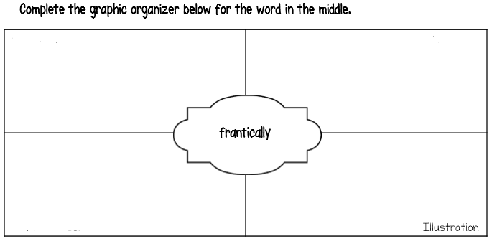

Synonyms (words that mean the same!)

Antonyms (words that mean the opposite!)

Write it in a sentence…

