Verbs: Perfect forms
Hello Year 6
Today you are going to look at the Perfect form of verbs. This form/tense uses has or have in the present and had in the past followed by a past tense verb. Please watch this video which looks at the perfect tense (as well as recapping on the progressive which we covered in school a while ago).
https://www.youtube.com/watch?v=7GAjEdOiNaI&feature=youtu.be
Then read the information below and have a go at the 2 activity sheets. The way I try and remember this form is Perfect uses Had/Have/Has- HP- Harry Potter is PERFECT!
When you have finished (look what tense I used!) and if you would like me to see your work or let me know how you got on please email me at ckozyra@mobberley.cheshire.sch.uk

Thank you Year 6- have a fantastic Tuesday!
Mrs Kozyra

The present perfect explained
We use the present perfect tense to talk about our experiences in a way that does not refer to when they happened:
I have never been abroad.
We also use this tense to talk about an action which started in the past and is continuous up until now:
I have been a doctor for ten years.
We also use this tense to talk about something that has happened in the past but has a result in the present:
I have lost my passport.
(The result in the present is that I don't have my passport).
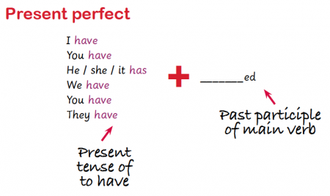

The past perfect explained
The past perfect is used to talk about an event that was completed in the past before something else happened:
I had just finished cooking the meal when my guests arrived.
I didn't want to watch the film, as I had already seen it.
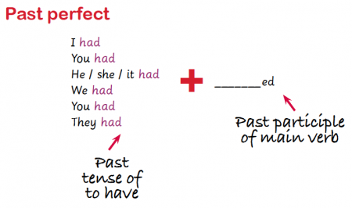

How this may look in a SATS question:
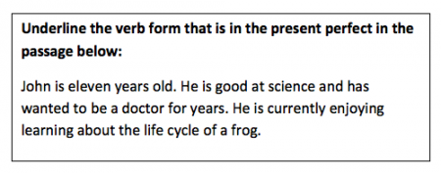
Answer: has wanted

