3 tbsp | olive oil
1 | onion, chopped
2 | stalks of celery, chopped (optional)
1 | clove garlic, crushed
400g | canned plum tomatoes
1 tbsp | tomato paste
1 tbsp | 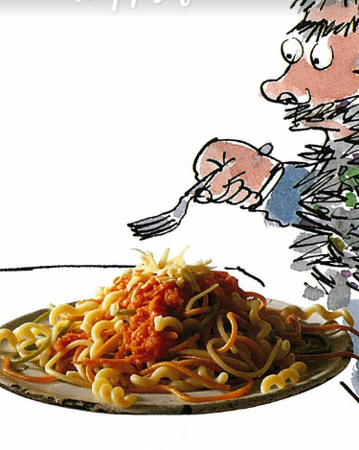  chopped fresh parsley
1 | bay leaf
1 tsp | sugar
2 | carrots, grated
56g | salt and pepper
2 ounces | fusilli
225g | tricolour spaghetti (2 ounces spinach, 2 ounces whole-wheat, and 4 ounces regular spaghetti)
6 | ounces Cheddar cheese

You will need: A medium and a large saucepan
1. Heat 2 tablespoons of oil in a medium saucepan and cook the onion, celery, and garlic over a low heat, covered, until soft.
2. Add the remaining ingredient for the sauce except the carrots. Bring to a boil and simmer for 30 minutes.
3. Remove the bay leaf and purée the sauce until liquefied. Return the sauce to the saucepan, season with salt and pepper to taste, and keep warm.
4. Meanwhile, bring a large saucepan of water to a boil and add a tablespoon of oil and a pinch of salt. Break the fusilli and the tricolour spaghetti into thirds and cook until al dente, about 5 to 10 minutes.
5. Fold the grated carrots into the sauce and heat through.
6. Serve the spaghetti on individual plates, topped with the sauce and grated cheese.

