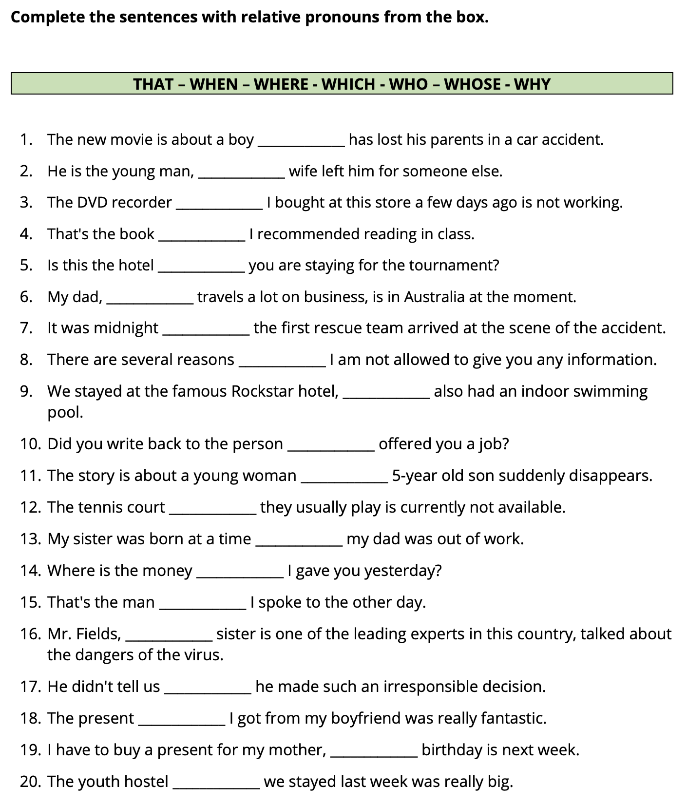
Year 5 English Homework – Relative Pronouns

