Charlie and the Chocolate Factory
Reading Questions
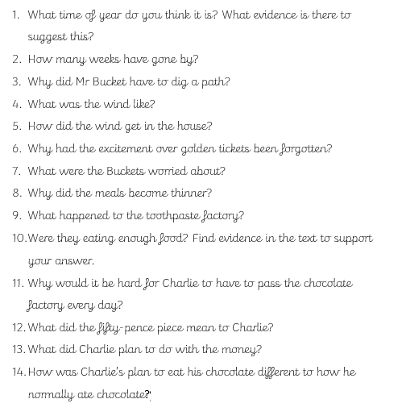
Chapter Ten

