Ratio Questions

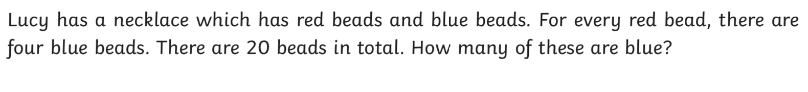
1

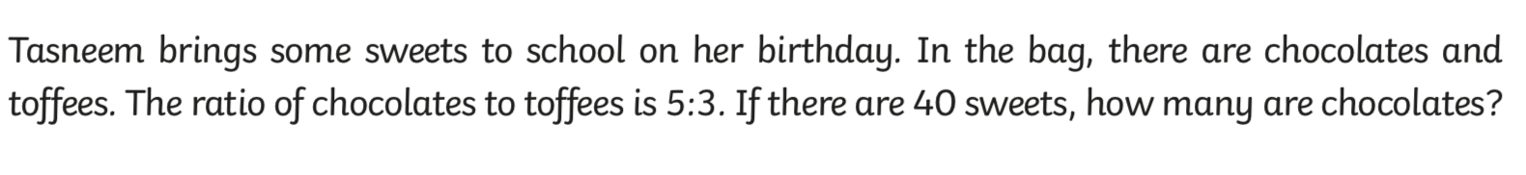
2

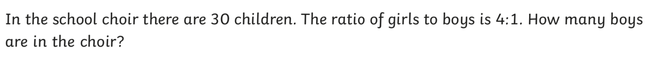
3

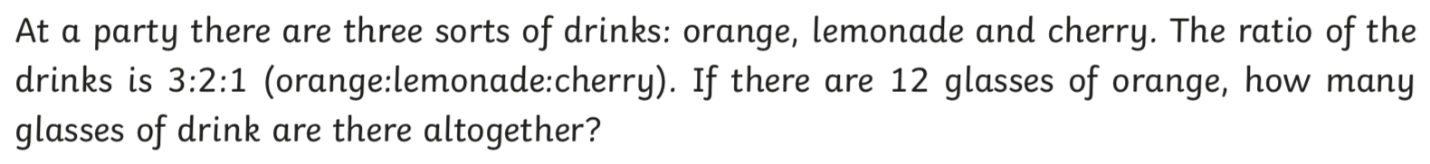
4

5. A bag contains 60 marbles, some blue and some green. The ratio of blue marbles to green ones is 1 : 5. How many blue marbles are there?

6. There are 20 children in a playground. The ratio of boys to girls is 2:8. How many boys are there in the playground?

7. There are 48 beads in a jar. For every 2 purple beads there are 6 red beads. How many red beads are there altogether?

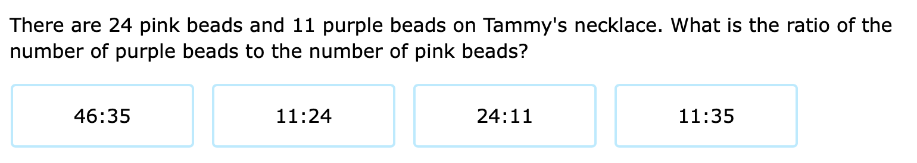
8

9. Alice fed 28 fish to a mother seal and baby seal. The mother seal had 5 fish for every 2 fish for the baby seal. How many fish did Alice feed the mother seal?

Answers

- 16 blue beads
- 25 chocolates
- 6 boys
- 24 drinks
- 10 blue marbles
- 4 boys
- 36 red beads
- 11 : 24
- 20 fish

