Adding Decimals within 1
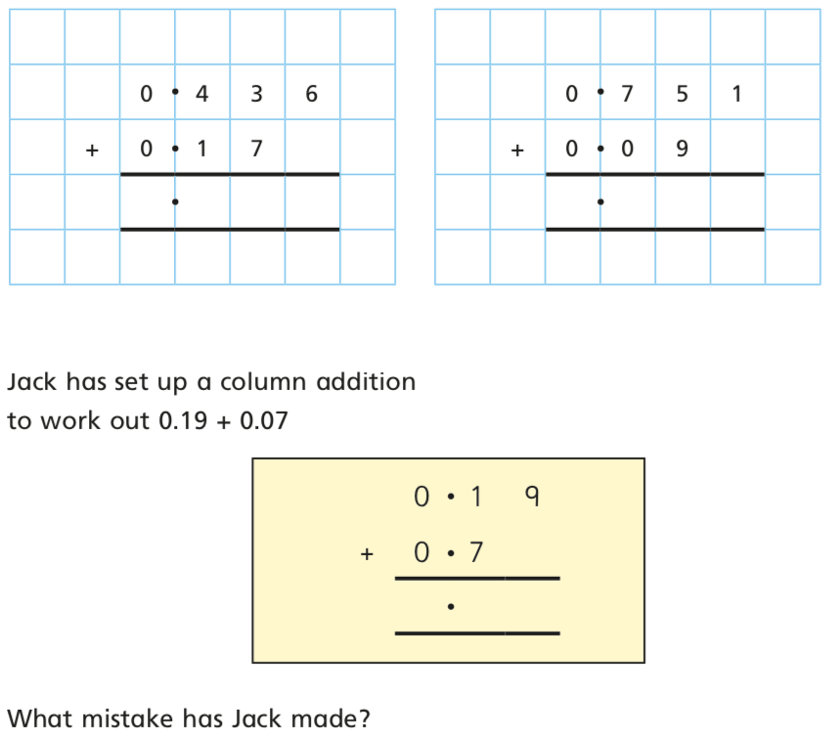

Set out the calculations below correctly and answer:

