Year 6 Autumn Term 2
Evolution and inheritance pre-assessment
What was the name of Charles Darwin’s scientific theory?
Can you explain what each of the following words mean? | Adaption  Inheritance
What did Charles Darwin discover about the Finches on the Galapagos Islands?
Can you explain the ways in which an arctic fox is adapted for the habitat in the picture? | 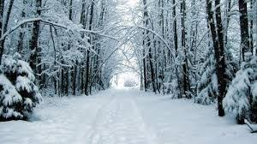
How was Darwin able to use fossils to prove his theory?

Marks

