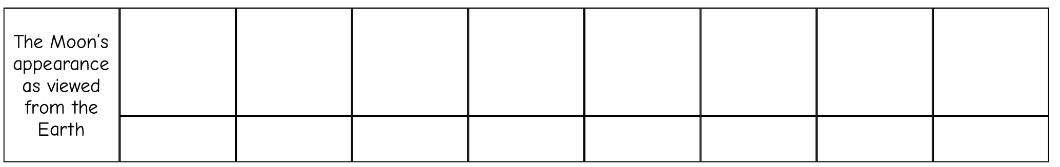

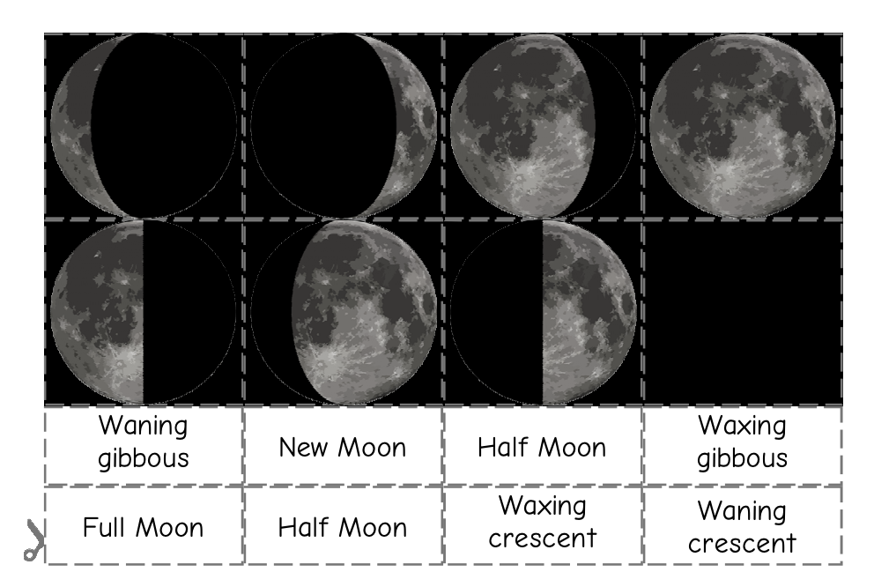

Cut out the pictures and titles and place them in the correct order above