Personification support sheet 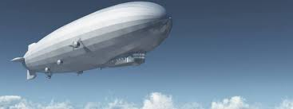

Sentence openers/adverbs to use

* Suddenly,
* Without thought,
* Desperately,
* Afterwards,
* Next to the ____,
* On top of the ____,

Verbs to use

* growl
* whimper
* shudder
* glinted
* protruded
* ebbed
* danced
* gripped
* yanked
* sought
* flipped
* sang
* dived
* drank
* skipped
* screamed
* sailed
* clenched
* sprinted
* flung

Things you could describe

* air rushing past outside
* the floorboards moving
* the canvas of the airship being torn
* the structure falling apart
* The weather – rain, wind, thunder
* The weapons being thrown at you
* The other airship chasing you/pulling you towards it
* Items on the shelves falling off
* The windows moving
* The steering wheel
* The escape pod
* Maps tearing and moving around