Pablo Picasso

Like Kandinsky, Pablo Picasso used colours to show mood and feelings.
Picasso’s blue and rose periods were formed following experiences of both tragedy and happiness.

“Colours, like features, follow the changes of the emotions” Pablo Picasso

Picasso’s Blue Period between 1900 and 1904

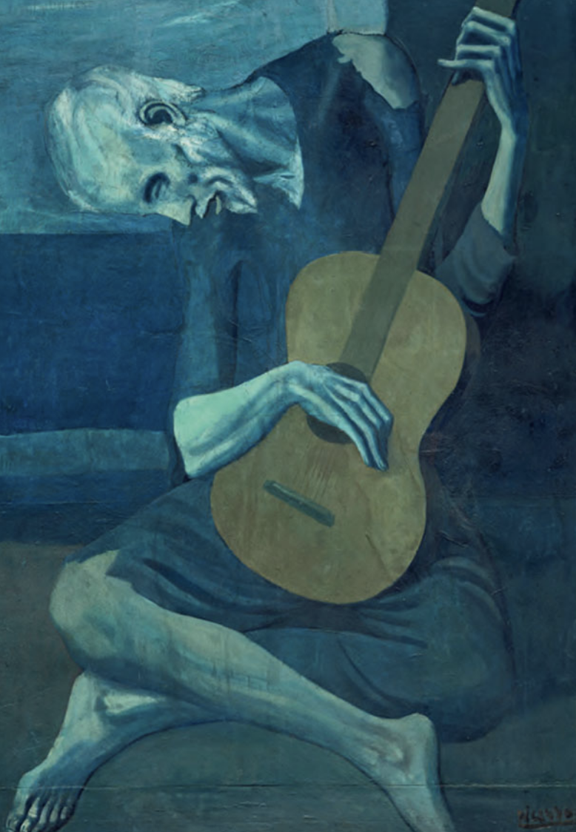
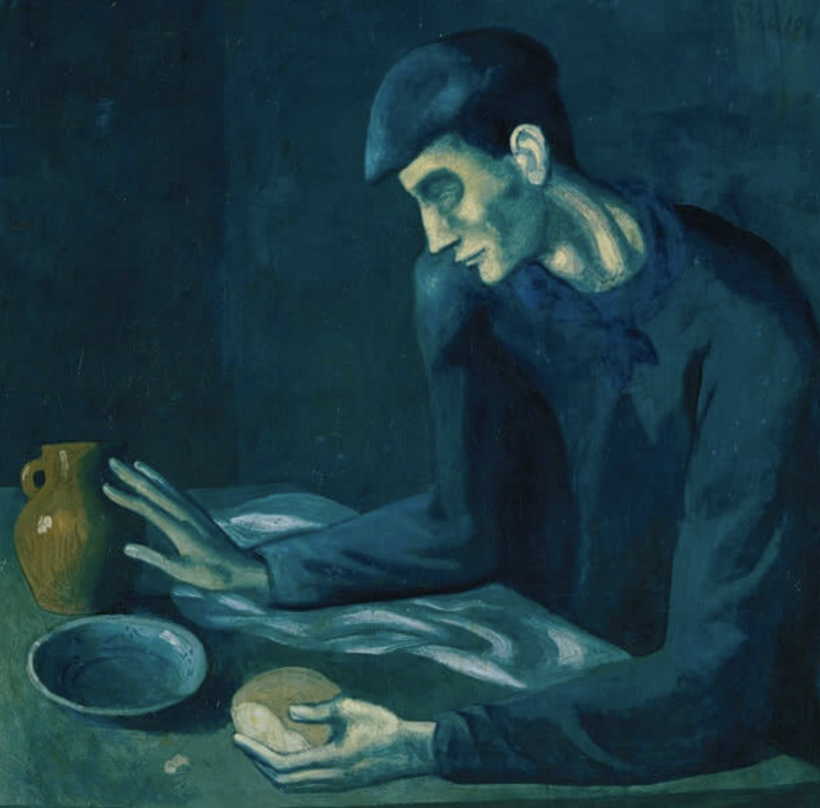
The Tragedy 1903 The old guitarist 1903 The Blindmans’s Meal 1903
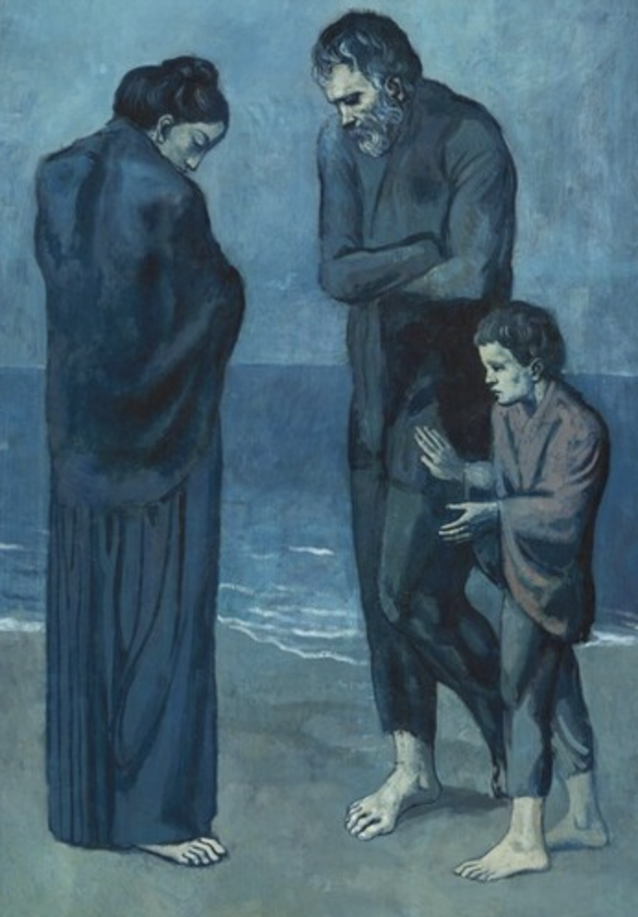

Picasso’s Rose Period between 1904 and 1906
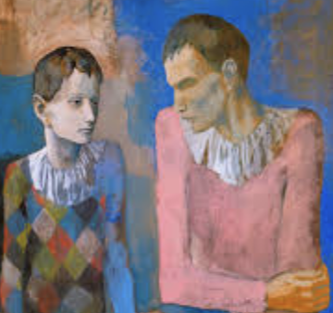
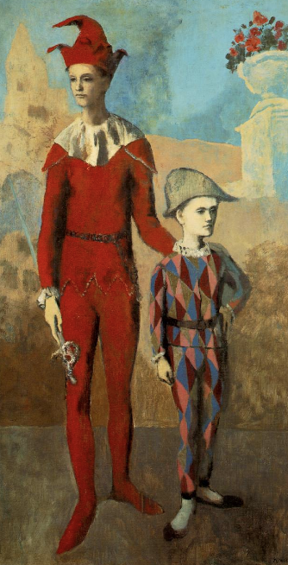
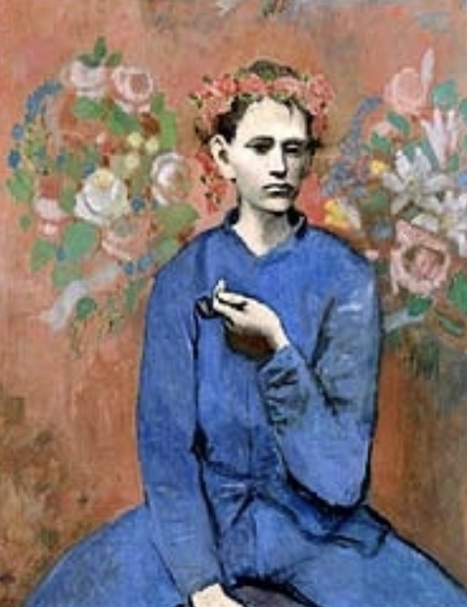

Pablo Picasso and Cubism 1907 onwards
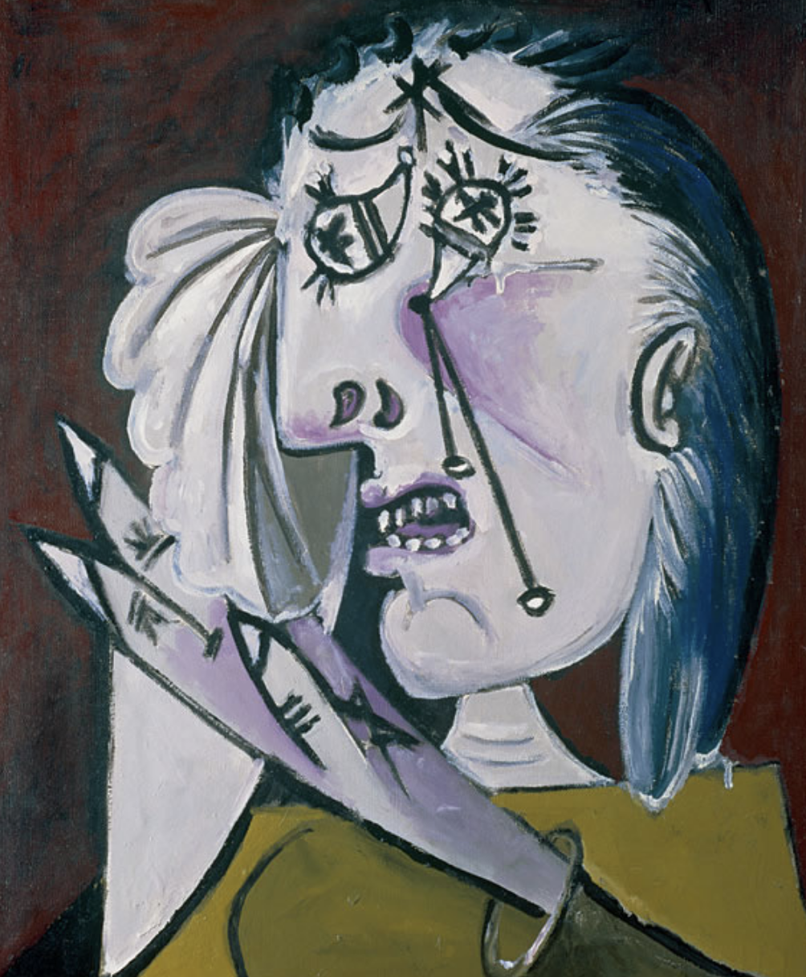
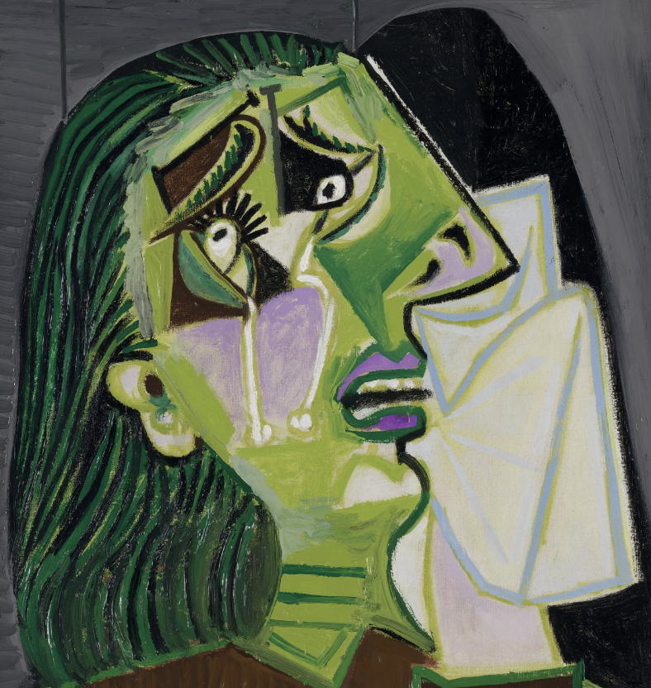
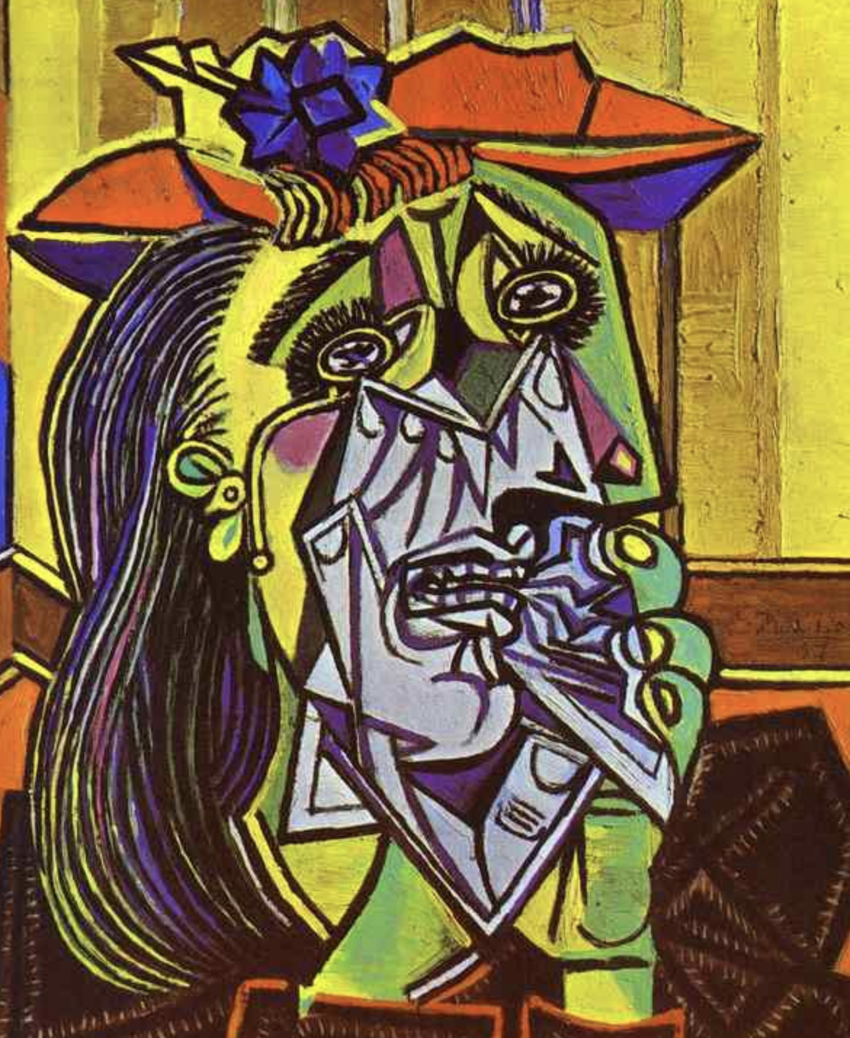

These are all titled ‘Weeping Woman’ by Pablo Picasso

Task 1: Watch the video on emotion in artwork
ishttps://www.youtube.com/watch?time_continue=120&v=6fJ32p8e8e8&feature=emb_logo

Task 2: Can you create a piece of artwork in the style of Picasso which uses colour, facial expression and shape to show emotions?

