On Sudden Hill by Linda Sarah and Benji Davies - Writing Activities
The photo story and transcript are on the Year 2 class page.
The resources/sheets for these activities are on the following pages of this document in order.
Monday  SC: I can use adjectives and similes. | Read up to “It’s got…it’s got WHEELS!”  Imagine you are Birt seeing the box car for the first time!  Use interesting adjectives (noun phrases) and similes to describe the box car (picture sheet below).  Noun phrase = adjective followed by a noun – huge wheels.  Simile = as _______ as ________ / ______ like a ______  e.g. ribbons as colourful as a butterfly / bright ribbons like a butterflies wings.
Tuesday  SC: I can write a set of instructions. | Read up to “A sparkling glitter king!”  The boys play with the box in different ways.  Make up a game they could play with the box and write a set of instructions (template sheet below).  Remember to include a How to heading, things you will need, numbered steps and bossy verbs!
Wednesday  SC: I can write a menu. | Read up to “It’s even got boxes inside. One with biscuits and one with lemonade.”  The boys have a lovely picnic together. Design a menu for a picnic. Maybe you could even make the food on your menu and have your own family picnic! (Template below).
Thursday | Handwriting  Spellings from HF words or phase 3,4, 5 phoneme spellings on website.
Friday  SC: I can retell a familiar story. | Finish the story.  Free choice – either retell the story in your own words OR draw a comic strip of the story. Take your time if your choose to draw and colour in the comic strip.

Monday 27th April 2020
SC: I can use adjectives and similes

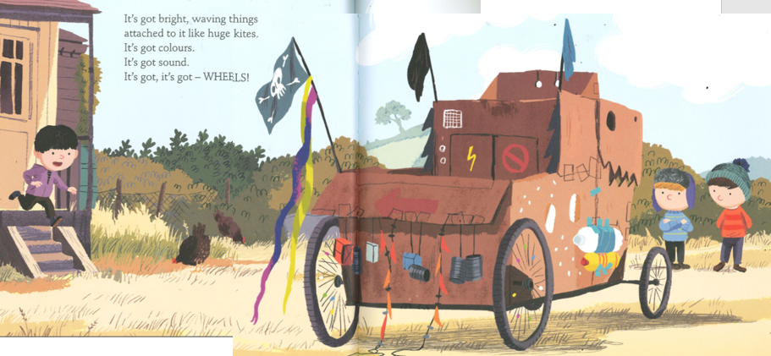

Tuesday 28th April 2020
SC: I can write a set of instructions

How to play _______________

Things you will need:
- ____________________
- ____________________
- ____________________
- ____________________

What you do:
1)
2)
3)
4)
5)

The aim of the game is to ________________________.
You win by ___________________________________.
You lose if ____________________________________.

Wednesday 29th April 2020
SC: I can write a menu for a picnic.
Menu
Deserts
Mains
Starters

Friday 1st May 2020
SC: I can retell the story in my own words.
OR SC: I can draw a comic strip of the story.

