On Sudden Hill by Linda Sarah and Benji Davies - Writing Activities
The photo story and transcript are on the Year 2 class page.
The resources for these activities are on the following pages of this document in order.
Monday  SC: I can describe what makes a good friend. | Read up to “Birt loves their two-by-two rhythm” using the photo story.  Birt and Etho are good friends. Inside the outline of a person write all the qualities that you think make a good friend.  Then write down 3 things you will do for your friends when you next see them.
Tuesday  SC: I can describe a setting. | Look at the picture of Birt and Etho sitting on top of the shed (use resource included). Describe what they are looking at, what can they see, hear, feel, smell.
Wednesday  SC: I can write in first person. | Read up to “One night, Birt smashes his box, stamps on it, rips it to shreds.”  Imagine you are Birt’s friend, what could you say to him about what he’s done, how could you make him feel better? You can write or record what you would say!
Thursday | Handwriting  Spellings from HF words or phase 3,4, 5 phoneme spellings on website.
Friday  SC: I can describe how a character might be feeling. | Read up to “Birt stops going up Sudden Hill.”  Use the picture of Birt sitting on his porch alone.  Write down Birt’s thoughts and feelings at this moment in speech/thought bubbles.

Monday 20th April 2020
SC: I can describe the qualities of a good friend

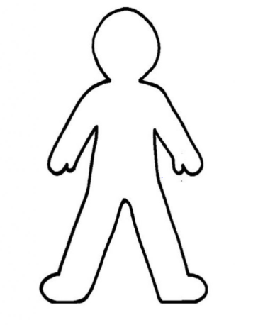

Three things I will do for my friends when I next see them:

Tuesday 21st April 2020
SC: I can describe a setting.
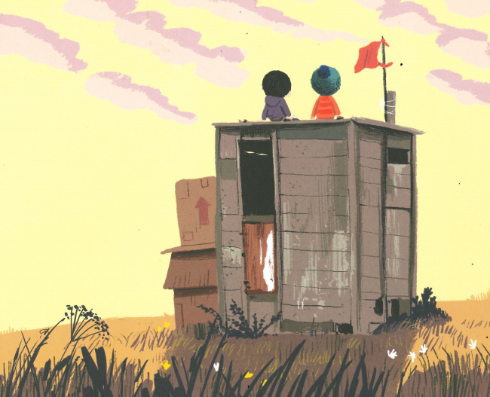

Wednesday 22nd April 2020
SC: I can write in first person.
Write down what you would say to Birt about what he has done. Try to make him feel better about the situation.
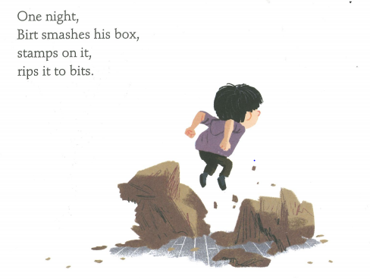

Friday 24th April 2020
SC: I can imagine how a character might feel.

