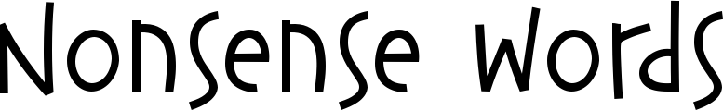

Nonsense Word: | What do I think it means?

