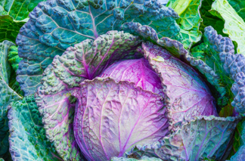
Mrs Bucket’s Cabbage Soup
- 1 teaspoon olive oil
- 64g chopped onion
- 1 clove of garlic, crushe
- 4 cups cabbage (256g) coarsely chopped
- 4 cups water, chicken or vegetable stock
- 1 bay leaf
- 1/2 teaspoon salt + pepper to taste
Instructions:
- Heat oil in a medium soup pot and saute onion & garlic for 2 minutes.
- Add cabbage, cook and stir for a minute.
- Add water or stock, bay leaf, salt, and pepper to taste.
- Bring to a boil, reduce heat, cover and simmer for 10 minutes.
Variation: Mrs Bucket sometimes adds one carrot, sliced 1/8-inch thin, along with the cabbage.

