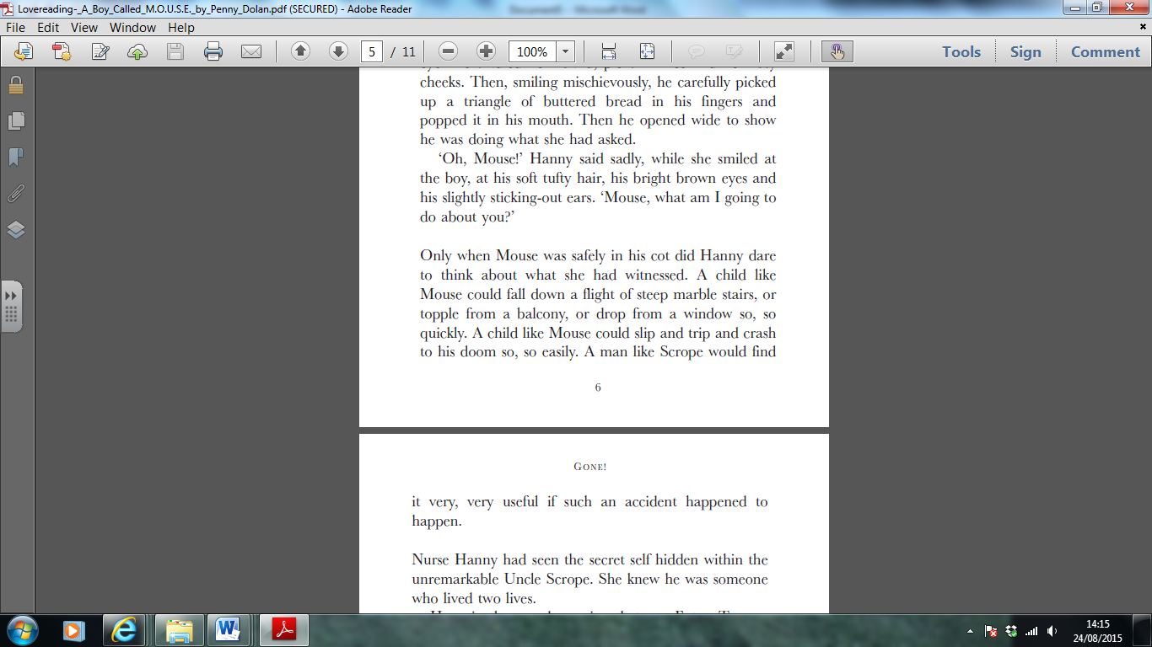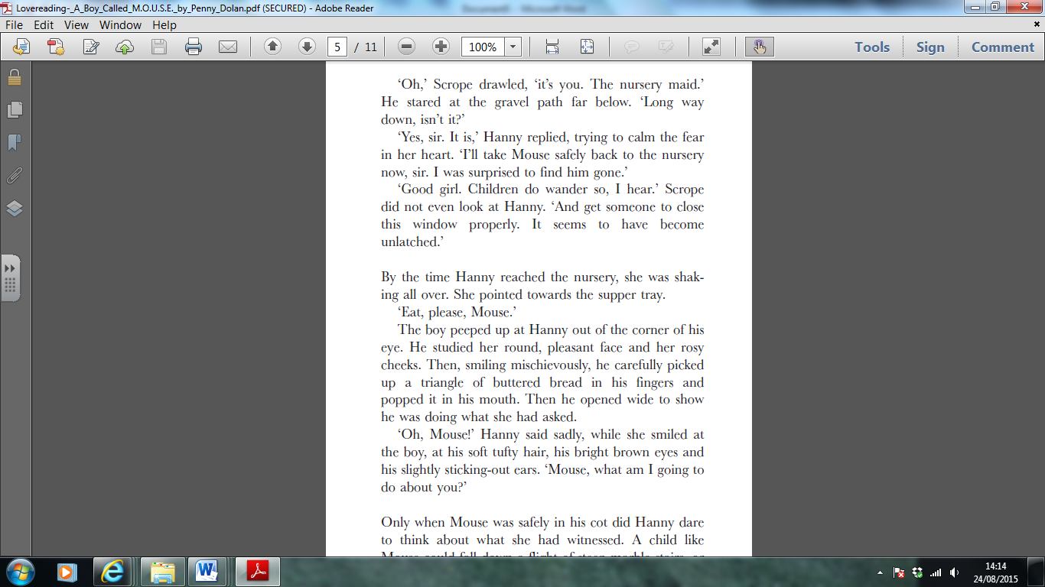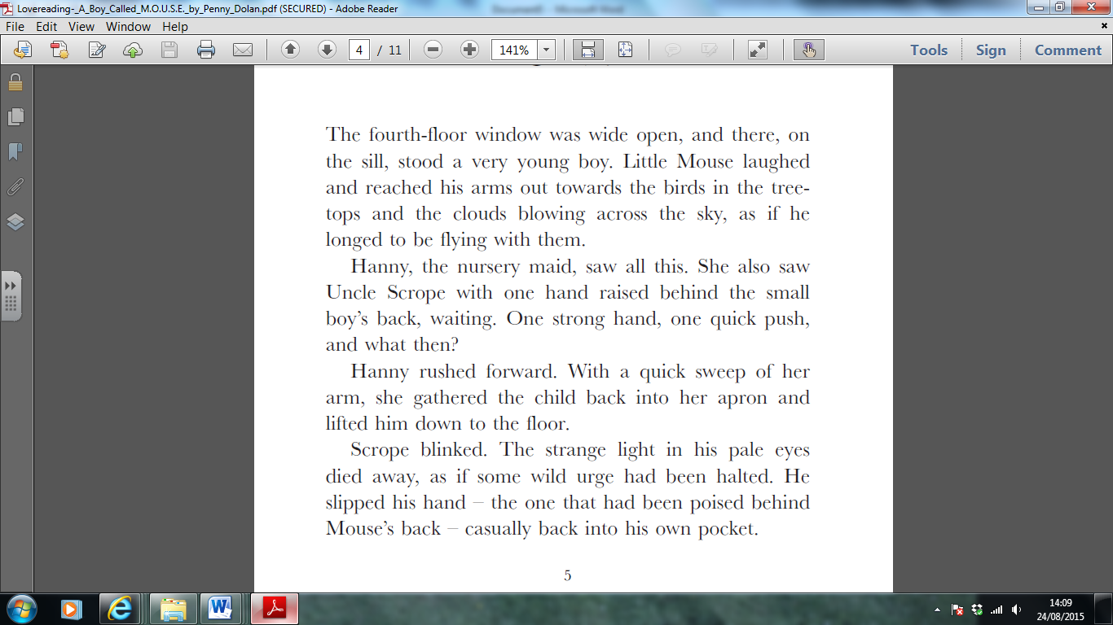From ‘A Boy called M.O.U.S.E’ by Penny Dolan

Retrieving Information

1. Use a dictionary to find the meaning of:
2. urge
3. poised
4. What is Mouse having for supper?
5. What time of day are the events in the text happening?

Making Inferences

1. Do you think this text is set in the past or nowadays? Why?
2. Why do you think Hanny says nothing about what she saw to Uncle Scrope?
3. Why might Uncle Scrope want Mouse to have an ‘accident’?

Writer’s choices

1. Why do you think the writer opens the text with a description of the birds and the trees and clouds?
2. Why do you think the author has chosen to give Uncle Scrope “pale eyes” and Mouse “bright brown eyes”?

Challenge question (extended answer)

1. Do you think Mouse comes from a rich or a poor family? Explain why, using evidence from the text.