- What do you think webspectacles are?
- Words or phrases in the paragraph below let us know that Jazz is feeling uneasy?
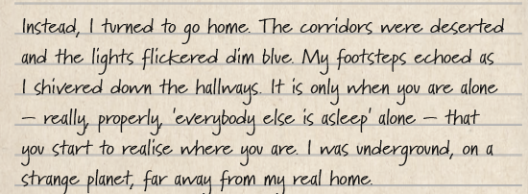
- What does the word ‘uninspiring’ mean?
- How do you know Letitia does not like Jazz and Elijah?
- Why do you think Letitia is being so mean to them?
- Read page 67 and 68. Can you draw a picture of one of the spacesuits?

