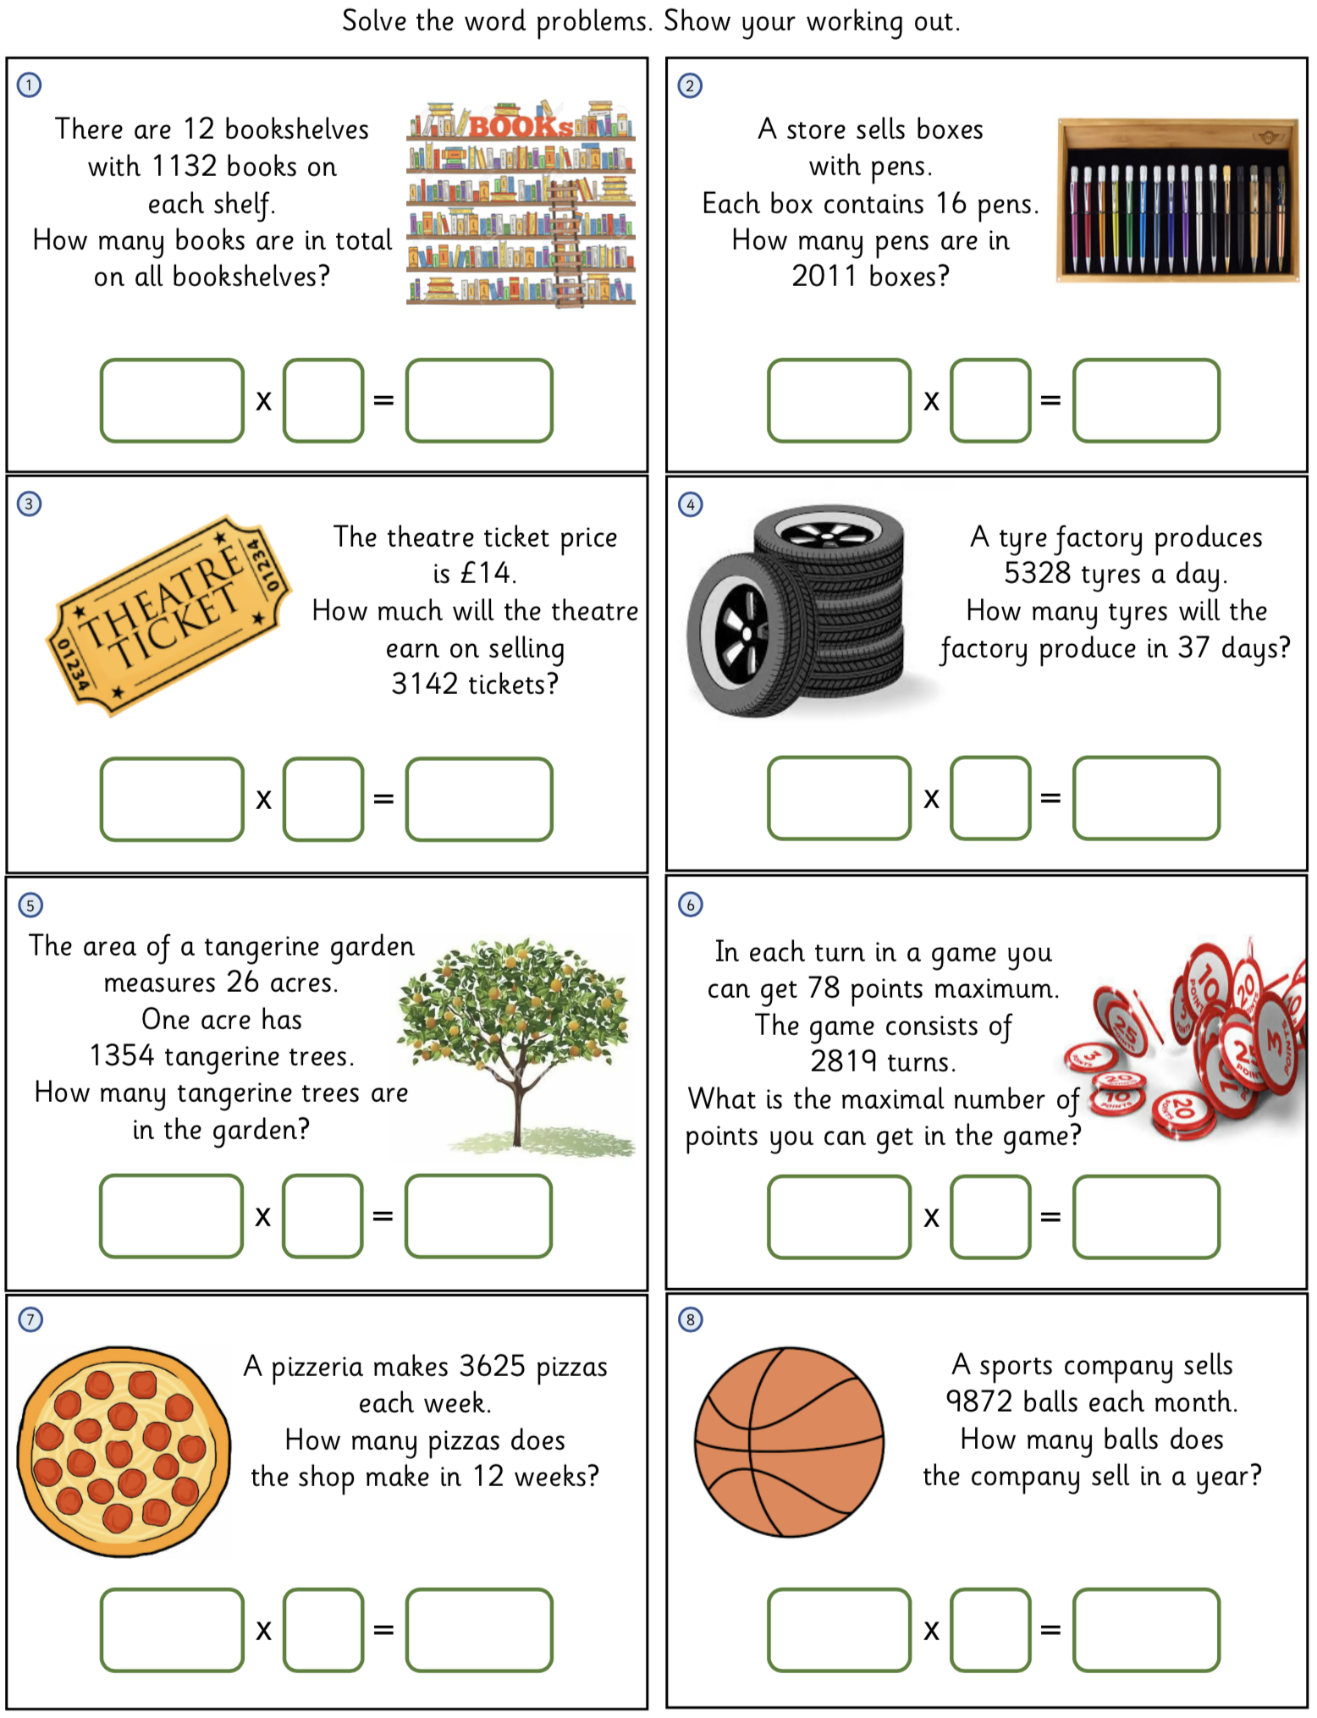
Multiply 4-digits by 2-digits

