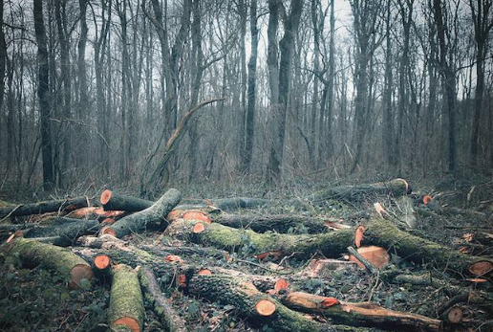
What do you think the link between both of the pictures might be?

Can you see any people in either of the pictures? If you can, describe as though you are telling somebody who can’t see the picture.
____________________________________________________________________________________________________________
Do you have any questions about either of the pictures? List them below…
__________________________________________________________________________________________________________________________________________________________________

Write a simple setting description based on the picture above.
Some sentence starters you might use:
This place was unlike any I had ever seen…
All around me…
The logs lay on the ground like…
The air felt…
The trees loomed over me as though they were…

