Message from Mrs Eadie 6th July (WK16)
Hi all,
Hope you all keeping safe and well and looking forward to doing some more lovely singing and music activities this week!
Don’t forget you can send me any music work or ask any questions by using my e-mail address jeadie@mobberley.cheshire.sch.uk


LOVE MUSIC TRUST LESSONS

As well as the LMT music lessons you may have noticed there are additional lessons which are set by me and you can choose to do whichever and however many you wish!

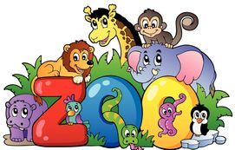
EYFS/KS1 https://www.youtube.com/watch?v=l6B_UD-QBuQ
This week’s lesson continues Betty Bear’s adventures at Chester Zoo. The first part of the lesson starts by revisiting the songs we learned last week, then adding instruments and finally learning The Butterfly Song as a round (which is where 2 or more singers sing the same song but starting at different time which is quite tricky to concentrate just on your own bit!!). The second part of the lesson is to learn some new songs starting with the Elephant Dance, then the Animal Song and finally finishing with Oh! We Went to Chester Zoo.

EYFS https://youtu.be/zWsN1EFGKkc

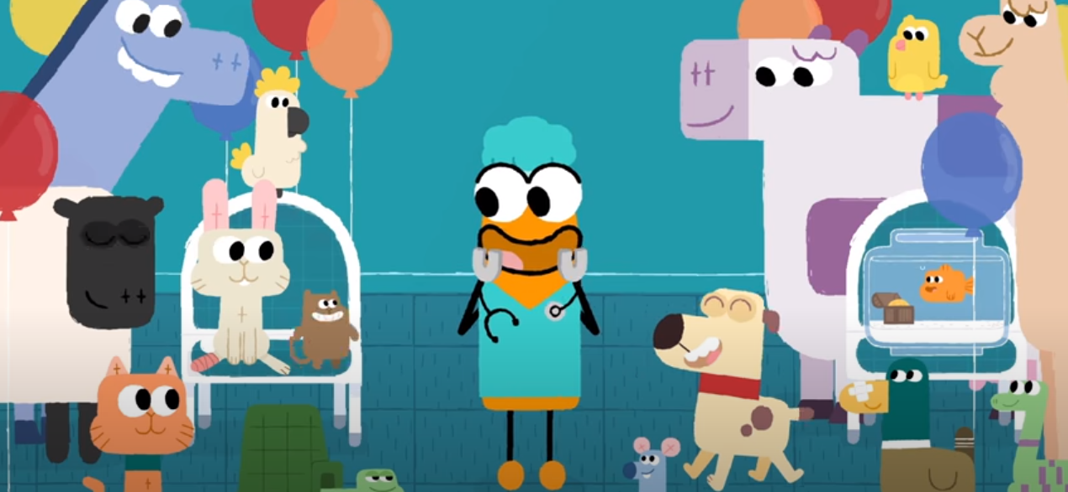
Here is a great song all about vets which links in with your Topic work ‘People Who Help Us’ and this week’s lessons around animal doctors or Vets! It’s very fast and you have to listen very hard to hear all the animals they are singing about!
How do you feel when you hear this song? Do you feel very happy, excited, exhausted! Does it make you smile, laugh or do you feel sad, miserable, gloomy and sleepy? Do you know what it is about the song or music that makes you feel like that? Send me a message or draw a picture and let me know!

YR1/YR2 https://www.bbc.co.uk/teach/school-radio/music-ks1-sun-sea-song-2-theres-a-hole-in-the-bottom-of-the-sea/zvr7jhv
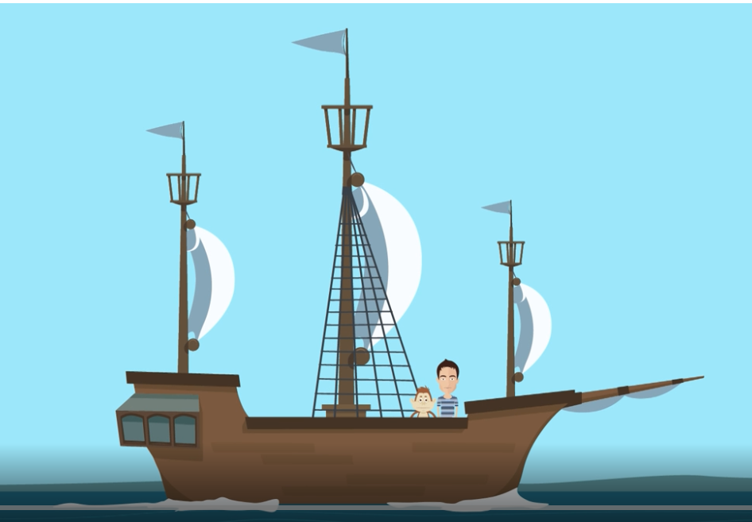
This week we are continuing with YR2’s topic Beside the Seaside and will be exploring PITCH (whether the sound is high or low), and RHYTHM in this week’s music lesson. You can find the words to the song at the end of this letter. When you have listened to the song watch the activity section and try keeping the PULSE by clapping 4 beats. See if you can manage to keep the beat as the verse gets longer and longer!

KS2 - https://youtu.be/FBP9OkqLgDk
This week’s lesson is focusing on 3 beat rhythms. Have a go at writing your own 3 beat rhythms using the sheet at the end of this letter. I have included some Rhythm Syllables for you to try out. Have a go at clapping them, saying the syllables as you clap. You may include rests in your composition! Can you remember what a one beat rest looks like? If not you could just use the word ‘sh’ to indicate a rest.

YR3/YR4 –https://www.bbc.co.uk/bitesize/topics/zcbkcj6/articles/z9ffng8
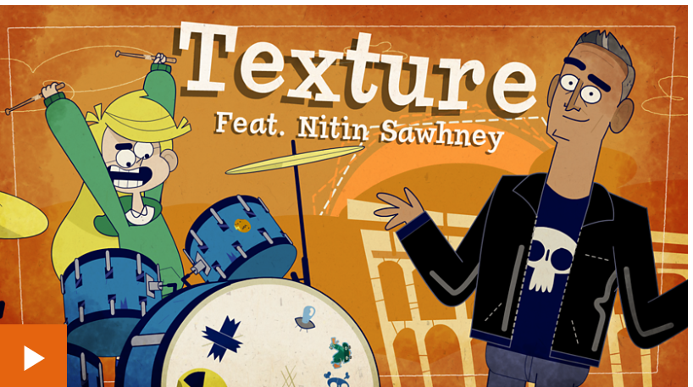
The Lightning Jelly Band are exploring TEXTURE this week featuring Nitin Sawhney. The TEXTURE of a piece of music means the overall sound created by multiple instruments and Nitin is an expert in this art! You can use everyday sounds to create your own music.

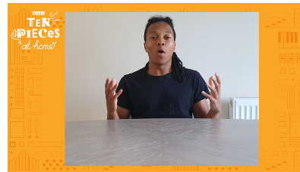
YR5/6 – https://www.bbc.co.uk/teach/ten-pieces/ten-pieces-at-home/zjy3382
Two weeks ago we listened to a great piece of music by Gabriel Prokofiev called Concerto for Turntables and Orchestra. We are using that piece this week to create a dance with a difference! Join dancer Jordan Douglas, in association with Sadler’s Wells to create your own table-top dance!
DAILY BIG SING
For the next few weeks we are learning songs from the ‘Music from the decades’ set of the Love Music Trust Big Sing project. This week we are visiting the 1980’s! As usual we start with a warm up song to get our voices ready to learn a new song.
I’ll give you the links and you can choose which ones you’d like to learn. It’s always a good idea to listen to the song before learning it so if you find the start of the song (near the end of the youtube video!) then you should be able to find it!
Monday Crazy Little Thing Called Love https://youtu.be/cvobl5T623M
The starter for this is an African call and response song called Hey unga wah
Tuesday Fame https://youtu.be/PyYRelzH2nE
Another visit to this lovely African call and response starter song A-bee-yo
Wednesday Only You https://youtu.be/nah3HJLSspc
The starter for this song is a lovely round song (where the same song is sung by different groups starting at a different time!) called Oo loola lay
Thursday Karma Chameleon https://youtu.be/b5L6CKQ8owc
Friday I‘m still standing https://youtu.be/1nMNPB4P_mk

OUT OF THE ARK SONGS
Have you tried this song called ‘In my Garden’? Try it. I’m sure you’ll like it! https://youtu.be/7PFiPEkgokg
You can still access all the 64 songs and activities that have been available over the last 12 weeks by clicking on the following link
https://www.youtube.com/playlist?list=PLxybjfxLKz_yOjX-gDbgJXmofWo__3OSX
SING UP
ALL – This week’s lovely song is called ‘I Can See Clearly Now’ https://youtu.be/tLdiAct3vEU
This is a great song from the 70’s and has an inspiring message about overcoming the hard times and having confidence that things will get better.

Quote of the week:-

“LEARN FROM YESTERDAY, LIVE FOR TODAY, HOPE FOR TOMORROW.”

Albert Einstein
Mrs Eadie
6th July 2020

Reception

THE VET SONG https://youtu.be/zWsN1EFGKkc

There's a special kind of doctor
Who can treat a cat or dog,
A cockatoo that's got the flu
Or a not-so-jumpy frog.
A well-trained veterinarian,
Most often called a vet,
Has just the skills to cure the ills
Of every kind of pet.

When a dog won't bark and a cat won't purr,
When a bird goes bald or a turtle grows fur,
When a rabbit's got a limp and an earache too,
When a cow goes, "Cough" when she should go, "Moo,"

When a horse gets hiccups and they just won't stop,
When a fish is all red from a belly flop,
When a gerbil has germs, you can bet that pet's
Gonna get much better when it sees the vet!

Now animals get sick of course,
The same as you and me,
But the vet can make them well again
And frisky as can be.

So when a hard-luck duck has a broken beak,
When a parrot's got a cold, and she just can't speak!
When a mouse gets mumps, you can bet that pet's
Gonna get much better when it sees the vet!

Yes, a pet'll get better when it sees the vet!

KS1 There’s a hole at the Bottom of the Sea

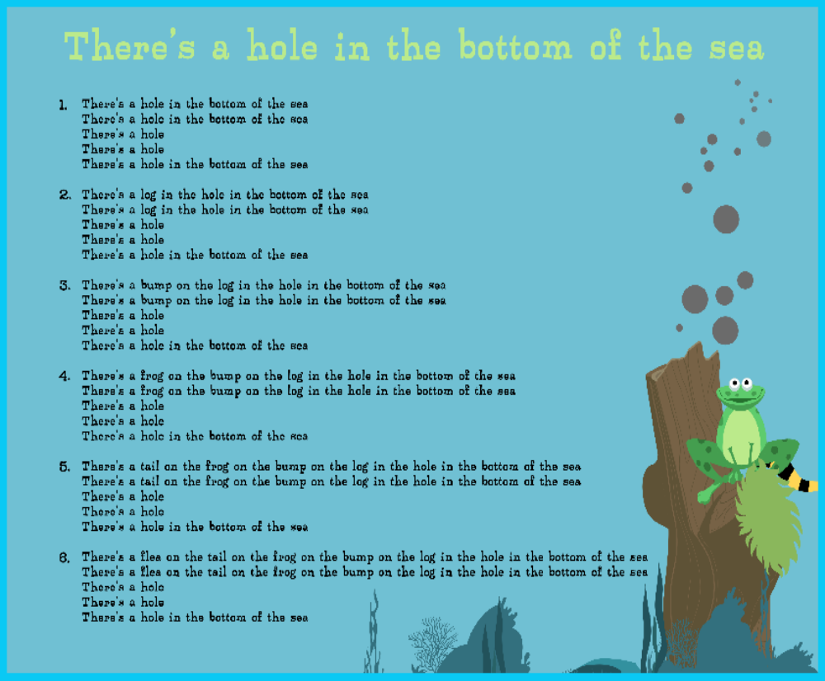

Create your own 3 beat rhythms

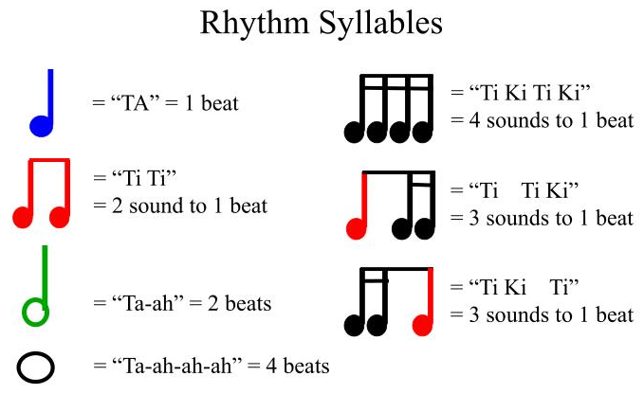

INSTRUMENT | 1 2 3 | 1 2 3

