Message from Mrs Eadie 29th June (WK15)

Hello everyone,
I hope you are all managing to keep up with your learning at home and enjoying trying lots of new things! Wasn’t the weather last week beautiful? but very hot. Make sure you put plenty of sun cream on and wear a hat as you sing and dance your way through this next week!! Don’t forget you can send me any music work or ask any questions by using my e-mail address jeadie@mobberley.cheshire.sch.uk

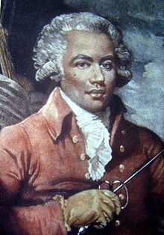
https://www.bbc.co.uk/teach/ten-pieces/ten-pieces-at-home/zjy3382
This week BBC Teach Ten pieces lesson at home features Joseph Bologne Chevalier de Saint-Georges, a very interesting and little heard of composer from the 18th Century. He was the first Classical composer of African ancestry who moved to Paris aged 13 with his father (a wealthy trader from Guadeloupe) and his mother (a slave whose family was from Africa). Listen to the report about his life and to the Allegro (fast) section from his Symphony No1. Joseph was a remarkable man who became a celebrity for his musical and sporting accomplishments.
If after listening to this you would like to take the challenge which is to write and present a news story about Joseph Bologne’s life and achievements. You may then (with parental permission) upload it to the website to go in the BBC showcase!

As well as the LMT music lessons you may have noticed there are additional lessons which are set by me and you can choose to do whichever and however many you wish!


LOVE MUSIC TRUST LESSONS

Here are your MUSIC lessons for KS1 and KS2 which continue to be delivered by the Love Music Trust. As well as our weekly music lessons, the trust continues to provide a Daily Big Sing during which you learn a warm up song and then learn step by step a new song.


EYFS/KS1 https://www.youtube.com/watch?v=l6B_UD-QBuQ
This week’s lesson is a singing journey as we join Betty Bear on her travels to the zoo. We start with a warm up Hello song then ‘Going to the Zoo’, ‘Alice the Camel’, ‘The Hippopotamus Song’, ’Feeding Time’, ‘Flutterby Butterfly’ then end with a Goodbye song.

EYFS https://www.youtube.com/watch?v=28yn_3BEraM

Here is a great song all about firefighters which links in with your Topic work ‘People Who Help Us’ and this week’s lessons around firefighters.
Can you join in with the Nee Naw! sound?
Does the sound go from high to low or low to high? Use your hand to show the shape of the Nee Naw sound, or show the sound using your body, standing, crouching or other ways you can think of. You can draw a picture of the Nee Naw sound and send it to me! Have a go and dance along to the rest of the song pretending to fight fires!


YR1/YR2 https://www.bbc.co.uk/teach/school-radio/music-ks1-sun-sea-song-1-the-big-ship-sails-on-the-ally-ally-oh/zb7spg8
This week we are linking in with YR2’s topic Beside the Seaside and will be exploring Tempo (how fast and slow a piece of music is), and Rests in this week’s music lesson. You can find the words to the song at the end of this letter.
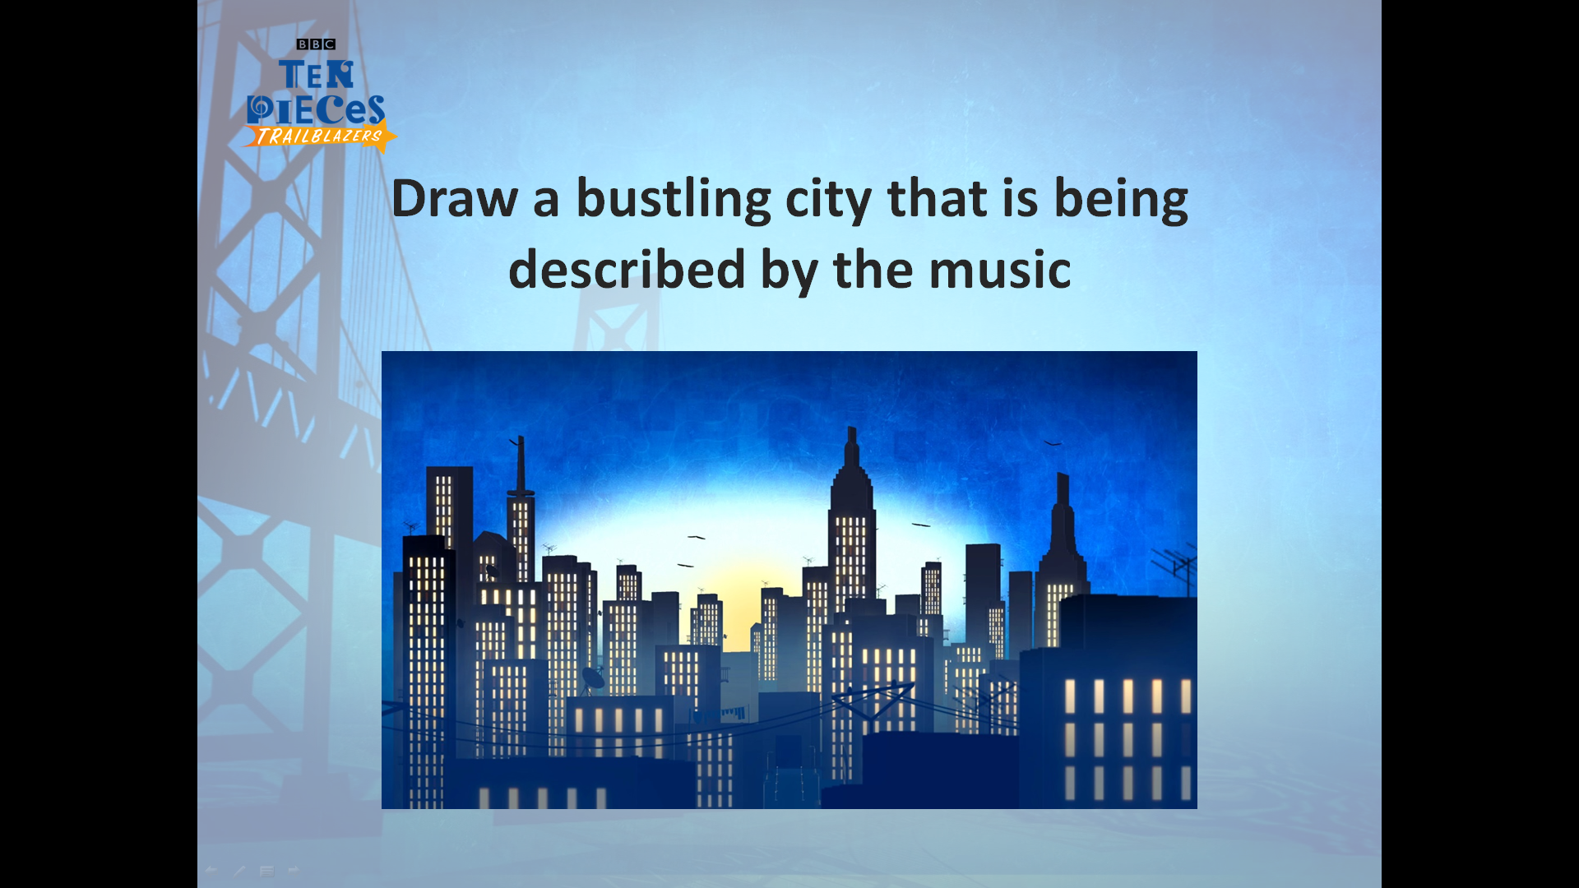
KS2 - https://www.bbc.co.uk/teach/ten-pieces/classical-music-george-gershwin-rhapsody-in-blue/zkcy6v4
In 1924 jazz and blues burst into the world of the classical orchestra thanks to trailblazer George Gershwin, who composed music full of the energy and playfulness of New York City in the 1920s.
We visit BBC ten pieces to learn all about George Gershwin. Packed with Gershwin’s own dazzling piano solos, Rhapsody in Blue has become one of the most famous orchestral pieces of all time. You might recognise parts of this piece. At the end of our music letter this week there is an activity sheet you might like to complete.

YR3/YR4 – https://www.bbc.co.uk/bitesize/topics/zcbkcj6/articles/z3yfng8
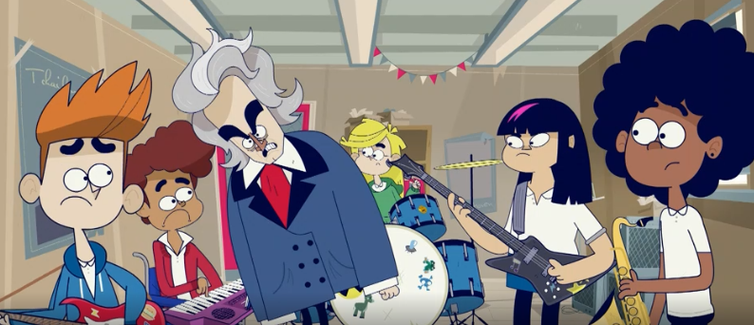
DURATION and TEMPO is this week’s lesson on musical terminology with the Lightning Jelly Band featuring no less that BEETHOVEN!! In this short clip Beethoven uses his 5th Symphony to explain DURATION and the music from the film Zorba the Greek to explain TEMPO.
After you have watched the cartoon clip, scroll down to watch the clip from Barney Harwood as he sheds light on Beethoven’s iconic 5th Symphony, arguably one of the finest pieces ever written.

YR5/6 – Last week’s lesson was all about creating your own mythical monster (A Bao A Qu!) If you would like to see some ideas sent in by other listeners to this piece, click on here https://www.bbc.co.uk/teach/ten-pieces/ten-pieces-at-home-showcase-week-nine/zv2gn9q
Please see article on Joseph Bologne Chevalier de Saint-Georges at the beginning of this letter.

DAILY BIG SING
This week’s songs are all connected with Africa and as usual we start with a warm up song to get our voices ready to learn a new song.
I’ll give you the links and you can choose which ones you’d like to learn. It’s always a good idea to listen to the song before learning it so if you find the start of the song (near the end of the youtube video!) then you should be able to find it!
Monday Maleezweh https://youtu.be/inmThFCw0eQ
Tuesday Siyahamba https://youtu.be/uYUfqWCBEWM
Some of you may recognise this as we have sung this in assembly in the past
Wednesday Si Si Si https://youtu.be/NBibPVSI7Tw
Hopefully some of the juniors will remember this as we have sung this many times in class!
Thursday Amane Utube https://youtu.be/Ptk7nM4yGRA
Friday Senwa Dedende https://youtu.be/FBeJStB90sk

OUT OF THE ARK SONGS
There are no new songs this week but you can still access all the 64 songs and activities that have been available over the last 12 weeks by clicking on the following link
https://www.youtube.com/playlist?list=PLxybjfxLKz_yOjX-gDbgJXmofWo__3OSX

SING UP
ALL –https://www.singup.org/singupathome/song-of-the-week RAISE MY VOICE
This is one of my favourite songs from sing up! Try and join in with the choreography. I’ve attached the words at the end of this message (apparently all I’ve been doing for the last few weeks is putting a picture of the zip file without any information on it – doh!!)
If you want to send us a clip of you dancing and singing some of this song, send it to your teachers and if we get enough back we’ll try and put together a video (make sure you ask parents first and record it in landscape!)
You can also access it on Sing up’s youtube channel here - https://youtu.be/szmKrOu0V4w


Quote of the week:-

“Life is a lot like jazz... it's best when you improvise.”
........George Gershwin


Mrs Eadie
29th June 2020

KS1 The Big Ship Sails

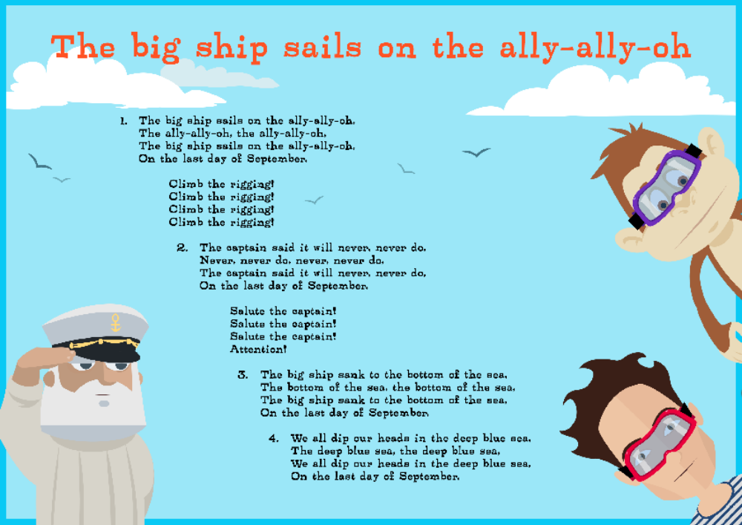

KS2

GEORGE GERSHWIN (1898–1937)
Rhapsody in Blue
Activity 1

Activity 2 When you have finished your drawing jot down short sentences or words to describe the music. Use your senses to help you.
Does it remind you of a particular place or thing.
What does it make you think of?
How did you feel when listening to it?
What do you see in your mind’s eye?

You can write these notes around your picture. Send your work to me by e-mail jeadie@mobberley.cheshire.sch.uk

I just love this piece of music....the opening few bars makes me feel like I’m swimming in melted chocolate!........ I wonder how it makes you feel!
Remember there is no right/wrong answers to this exercise. It’s just your thoughts and ideas!

RAISE MY VOICE

Eh, eh, eh, eh, eh, eh, eh. (x 2)
Got something to say, got a difference to make,
A part I can play and a role I can take,
I believe in myself, express how I feel,
I like who I am and I’m keepin’ it real.

Raise my voice, make a noise,
’Cos we’re all havin’ fun with it. (Fun with it.)
Can’t you see, this is me
And it’s OK to go for it. (Go for it.)
Raise my voice, make a noise,
’Cos we’re all havin’ fun with it. (Fun with it.)
Can’t you see, this is me
And it’s OK to go for it.
Makes me wanna sing!
Eh, eh, eh, eh, eh, eh, eh. (x2)

I want to be strong, live long and be safe.
My generation has something to say,
So much to learn, enjoy and achieve.
I reach for my goal to be all I can be.

Raise my voice, make a noise................
Eh, eh, eh, eh, eh, eh, eh. (x 2)

(Chanted) BULLYING? NO!
WORK TOGETHER? YES!
HIDE MYSELF? NO!
BE ME? YEAH!

Eh, eh, eh, eh, eh, eh, eh. (x 2)
Strong side by side, we lift those who fall,
Stand by our friends and we hear when they call.
Let’s all make a change, all play our part,
It takes you and me, and here’s where it starts:

Raise my voice, make a noise.......

Eh, eh, eh, eh, eh, eh, eh. (x4)

