Message from Mrs Eadie 13th July (WK17)
Hello everyone,
I hope you are all keeping well and enjoying a little bit more freedom as lockdown gradually begins to lift. I’ll bet it’s lovely to be able to meet up and stay over at Grandmas and Grandads again or meet up with other family members and friends..... at a safe distance of course!
It has been a very strange time for us all but we adapt and learn new skills and in years to come you will be able to tell and learn new skills and in years to come you will be able to tell your children all about the time when the virus came to visit our land!

This is the last musical message you’ll receive from me as we head off into the summer break but if any of you would like me to send you songs or activities over the summer then just email me and I’ll certainly see what I can do!
My email address is jeadie@mobberley.cheshire.sch.uk

LOVE MUSIC TRUST LESSONS

As well as the LMT music lessons you may have noticed there are additional lessons which are set by me and you can choose to do whichever and however many you wish!


EYFS/KS1 https://youtu.be/VTbQosdd6Ws
This week is the last lesson with Betty Bear and her adventures at Chester Zoo. The first part of the lesson starts by learning the final song called We Like to Come Out at Night. After that we go through the entire visit to Chester Zoo with Betty Bear.

EYFS https://youtu.be/3Mu2WhzIh1I

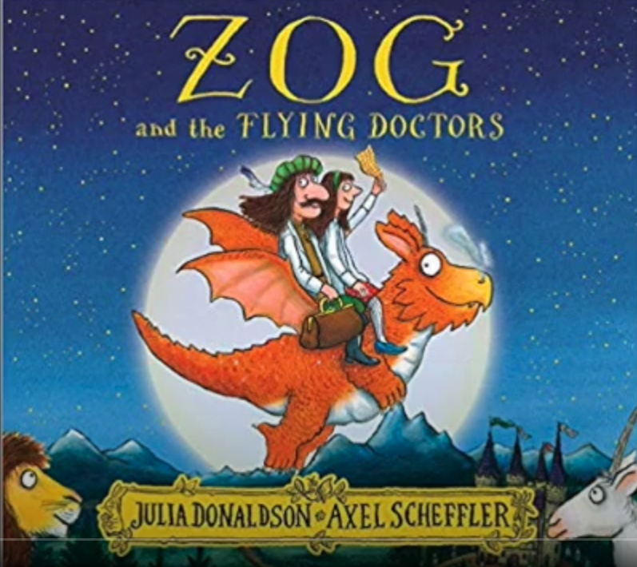
This is a great song to go with the ‘Flying Doctors’ book which you are working on this week in your English lesson. Julia and Malcom Donaldson perform ‘The Flying Doctors’ song to accompany Julia Donaldson and Axel Scheffler's picture book Zog. You can join in as the words are on the video! Enjoy!!

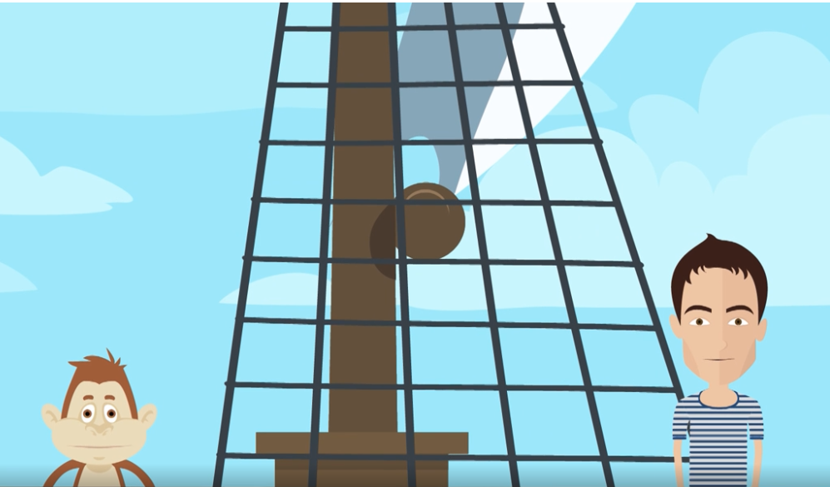
YR1/YR2 https://www.bbc.co.uk/teach/school-radio/music-ks1-sun-sea-song-3-my-ship-rolls-over-the-ocean/zkx3y9q
This week Nigel and Suki the monkey continue their adventure at sea and are caught in a storm! Linking in with YR2’s topic ‘Beside the Seaside’, we will be exploring PITCH (whether the sound is high or low). The words are attached at the end of this letter.

When you have listened to the song watch the activity section and copy Nigel, can you hear if he sings higher or lower? Can you make High/Low sounds? Perhaps you could tap things around the house and see if items have a different pitch when tapped, struck, banged or sounded any other way! Get a few glasses or jam jars and put different amounts of water in them. Tap them with a pen and see which ones are high pitched and low pitched. What do you notice?

KS2 - https://youtu.be/H8JH9TjF0ko
This week’s final lesson from LMT is about musical structure or FORM. All music has some kind of form and this week we will be exploring TERNARY where the structure is based on an A-B-A form (a musical sandwich!)

YR3/YR4 –https://www.bbc.co.uk/bitesize/topics/zcbkcj6/articles/z3x6msg
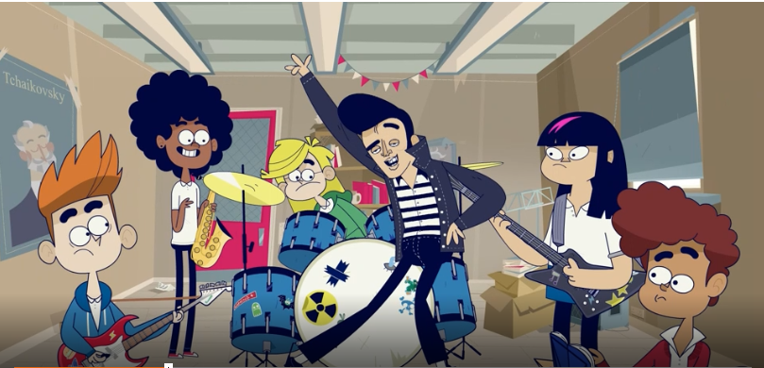
This week the Lightning Jelly Band have a very special guest - The King Of Rock’ n Roll ELVIS PRESLEY! He will help them to understand the STRUCTURE of a piece of music. The STRUCTURE is the order that different parts of the song are played in (like the sandwich described in this week’s LMT lesson).
Traditional pop music usually follows a verse/chorus/verse STRUCTURE. If you listen to your favourite pop song you might notice that it not only follows this structure but it will repeat the chorus as this is the catchy bit of the song.
As it’s the end of term you might want to do a little quiz to see how much you’ve learned with the Lightning Jelly Band! https://www.bbc.co.uk/bitesize/articles/z7ryy4j

YR5/6 – https://www.bbc.co.uk/teach/ten-pieces/ten-pieces-at-home/zjy3382
This week it’s all about beginnings!
FIRST, join Barney Harwood in exploring the music of Beethoven and one of the most famous motifs in musical history. It has even been used in pop songs! (You may have already seen this part if you have engaging in our weekly music lockdown lessons!)
THEN, join Dr Who composer Segun Akinola to explore beginnings and sets you a creative challenge based on Beethoven’s famous opening. You can create anything you like based on this opening, what do you think of when you hear it? How does it make you feel? What pictures spring to mind?

DAILY BIG SING
This is our last week of singing with the LMT and we are continuing to learn songs from the ‘Music from the decades’ set of the Love Music Trust Big Sing project. Some classic songs for you this week! Get mums and dads up to join you in this fabulous music set. As usual we start with a warm up song to get our voices ready to learn a new song.
Monday Never Gonna Give You Up https://youtu.be/OqGJUBWzaKk

Our warm up song today is an old favourite of the YR3’s Warm up and Stomp!! Go on, have a laugh and a dance!
Tuesday I’ll be there https://youtu.be/vrwEik7GlKk
Dr Knickerbocker is our warm up today
Wednesday Don’t look Back in Anger https://youtu.be/WR91pXgxh_s

Warm up this morning is the Mountain Song
Thursday I’m Spinning Around https://youtu.be/Y8hmSpIqr3w
The action song Tony Chestnut start our sing today
Friday Rock DJ https://youtu.be/CxYCMxjg0ko
Our warm up song today is an old favourite H.E.L.L.O

OUT OF THE ARK SONGS
Have you sat in the garden recently and heard the beautiful songs that the birds sing? They are all very different from each other yet all so beautiful and melodic. Try this song, called ‘I Heard a Blackbird Singing’? Try it. I’m sure you’ll like it! https://youtu.be/ebcDzNhrWCs
You can still access all the 64 songs and activities that have been available over the last 12 weeks by clicking on the following link
https://www.youtube.com/playlist?list=PLxybjfxLKz_yOjX-gDbgJXmofWo__3OSX

SING UP
ALL – This week’s song is called ‘Great Day’ https://youtu.be/xgwvebA19KY
Becky Owens will guide you through learning this joyful 4 part harmony song. Not as difficult as it first seems but does need a bit of concentration! Or just learn the main tune, whichever you do I’m sure you’ll love it!
The words can be found at the end of this letter.

AND FINALLY.........

This just leaves me to say have a very happy summer. It has been a great pleasure to keep you all up to date with all things musical and I look forward to seeing you all in September.

I would like to wish our lovely YR6’s all the very best as they set out on a new chapter of their lives and to thank them for their musical contributions over the last seven years in school. My final quote of the year is especially for them.


Quote of the week:- (from an ancient Chinese proverb)

”A journey of a thousand miles begins with a single step"
Lao Tzu




Mrs Eadie
13th July 2020

KS1 My Ship Rolls Over The Ocean

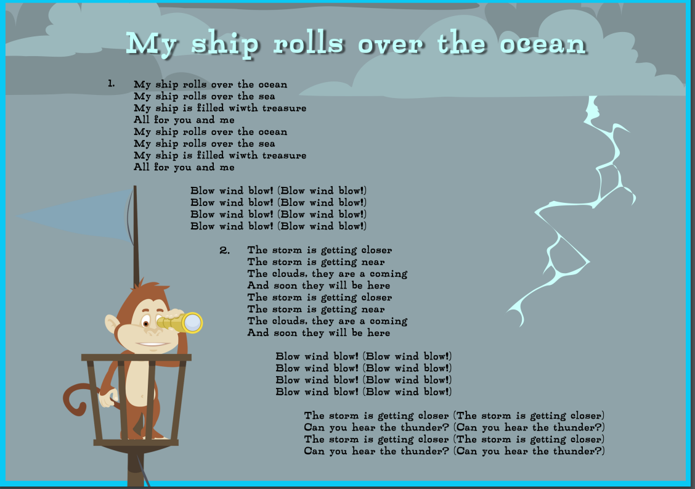

GREAT DAY!

(Melody 1)
Great day!
Great day and the sun is shining.
Great day!
The sun’s gonna shine on everyone.
(Melody 2)
Shine on! Shine on me, won’t you
Shine on! Shine on me, won’t you
Shine on! Shine on me.
The sun’s gonna shine on everyone.
(Melody 3)
Great day! The sun is shining on me.
Great day! The sun is shining on me.
Great day! The sun is shining on,
The sun's gonna shine on everyone.
(Melody 4)
Dvm, dvm, dvm,
Dvm, dvm, dvm,
Dvm, dvm, dvm.
Sun’s gonna shine on everyone.

