Well done to everybody who completed their MyMaths challenges last week! I will be choosing a MyMaths superstar who will receive a Miss Whalley certificate at the end of this week for their efforts!

Well done Bella for doing so well last week and earning a ‘MyMaths’ certificate and 5 housepoints!

Please continue to talk to your children about the time. Even just making comments like “It’s half past twelve so time for lunch!” or “It’ll be time for bed in twenty minutes”. Time is something that children really need to be immersed in to fully understand it and so please carry on all of the wonderful things you are already doing
Monday  Measuring and Drawing Lines with a Ruler | Resources:  A ruler measuring in CM  A pencil and piece of paper!  Today we are going to be learning to draw and measure straight lines with a ruler. It is something that sounds really simple but also something that we have to get right!  Watch this video of me having a go at using a ruler.  https://youtu.be/Z--8jWyAw04  Remember, instead of writing ‘centimetres’ or ‘millimetres’ we write CM and MM to be quicker.  Think about my measurement at the end of the video. Was I right or wrong? Why?  Your task today:  I would like you to design/draw a house using the measurements below. Make sure you use your ruler properly and carefully!  Door needs to be 5 cm tall and 3 cm wide.  Windows need to be 3 cm tall and 3 cm wide.  The walls need to be 10 cm tall and 10 cm wide.  Draw some flowers in front of the house! The stem need to be 2 cm tall.  (Optional)  Fancy another challenge? Have a go at the question below!  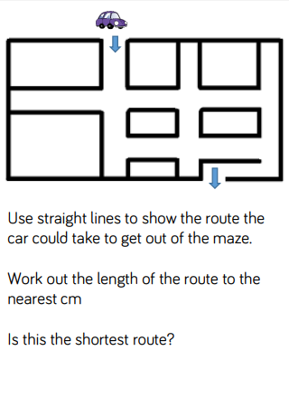
Tuesday  Vertical, Horizontal and Diagonal Lines | Resources:  Lines Venn Diagram  Vertical or Horizontal Powerpoint  Watch the video below to learn about some different types of line. How many did you know already? Did you hear some names for line that were new to you?  https://www.youtube.com/watch?v=DQEVllmeWH4  Remember, horizontal lines go across and vertical lines go straight down.  Look through the Vertical or Horizontal Powerpoint and see which types of line you can spot.  Your task today:  Now have a look at the Lines Venn Diagram. You will have to cut the shapes out first so be careful with your scissors and only use them if there’s an adult close by!  Arrange the shapes into the venn diagram depending on the types of line they are made up of. Some of them may not fit into either! Remember, the ones that are not in any of the sections go on the outside of the venn diagram.  Challenge (Optional)  Have a go at the challenge below!  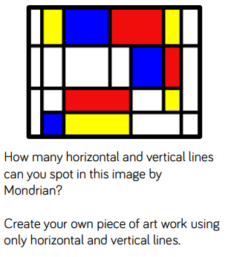
Wednesday  MyMaths  Lines of Symmetry | Today, I would like you to log into MyMaths and work through the ‘Lines of Symmetry’ lesson and homework.  If you have forgotten or lost your username/password, just left me know and I will email them to you  Remember to have a go at every question!  Enjoy
Thursday | Resources:  Identify Properties and Sort Shapes (Powerpoint)  Find Shapes- Match a Property  Work through the ‘2D’ part of the Powerpoint. Don’t look at the 3D section today!  Remember that vertices are a fancy word for corners but in maths we always say vertices rather than corners.  Today’s Task:  Now have a go at the Find Shapes- Match a Property activity. Remember to use a ruler when you draw the shapes into the right boxes!
Friday  Properties of 3D Shapes | Resources:  Identify Properties and Sort Shapes (Powerpoint)  Today work through the second half of the Identify Properties and Sort Shapes PowerPoint (the 3D section).  Your Task:  Have a look around your house for some objects. The last slide in the PowerPoint may give you some ideas for the kind of objects you could find.  When you have found your objects, think about their properties.  How many vertices do your objects have?  How many faces?  How many edges?  Which object has the most vertices/faces/edges?  Which has the least?

