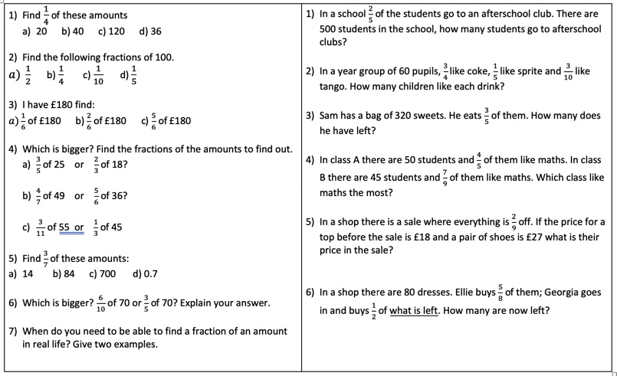
Maths Questions for 3/6/20 Year 6
2/4 like coke

