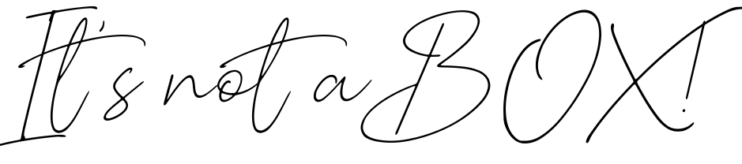

It’s ***not*** a box! So what is it?!