Illusion art

Here are some more ways to create illusion art:

3D hole | https://www.youtube.com/watch?v=KnZQYXPJnXU  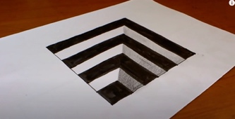
Ladder | https://www.youtube.com/watch?v=OAq2X-0FbGM  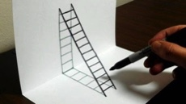
Floating A | https://m.youtube.com/watch?v=jr-zAzxfTVU  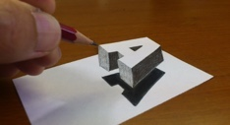
3D hole and stairway | https://m.youtube.com/watch?v=LcWLe_f-wQk  