1) Circle the sentences that are written in the past progressive.
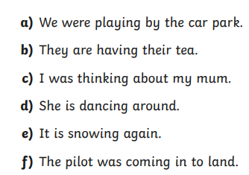
2)
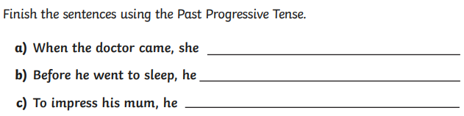
3)
