Hot cross bunny

Who's in a tizzy,
who's in a flap,
who's got a great big frown?
Who's in a tizzy,
who's in a flap,
who's jumping up and down?

Chorus
He's a hot cross bunny
and it's not funny
cos he's lost his Easter eggs.
He's a hot cross bunny
and it's not funny
cos he's lost his Easter eggs.

Who's got a niggle,
who's in a huff,
stamping his rabbit feet?
Who's got a niggle,
who's in a huff?
he's got no eggs to eat.
Chorus
He's a hot cross bunny ............
Who's hot and bothered,
who's in a grump,
who's looking high and low?
Who's hot and bothered,
who's in a grump,
where did his eggs all go?
Chorus
He's a hot cross bunny ............
Who's in a tizzy,
who's in a flap,
who's got a great big frown?
Who's in a tizzy,
who's in a flap,
who's jumping up and down?
Chorus
He's a hot cross bunny ............

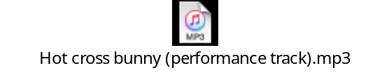

Butterfly
Butterfly so beautiful,
Coming out to play,
Flutter, flutter, flutter, flutter by,
Flutter float away.

Butterfly so colourful,
Coming out to play,
Flutter, flutter, flutter, flutter by,
Flutter, float away.

Butterfly so delicate,
Coming out to play,
Flutter, flutter, flutter, flutter by,
Flutter, float away.

Butterfly so beautiful,
Coming out to play,
Flutter, flutter, flutter, flutter by,
Flutter, float away.



