Half Term Homework – Geography
Over the holiday, I would like you to produce a poster about Europe and Russia. This will bring together and finish our topic on Europe including Russia.
You must include the following information in your poster and if you have any space left, you can add extra facts, information and pictures/photos.
Your poster only needs to be on an A4 sheet folded in half with half the sheet on Europe and half the sheet on Russia. It will be stuck into your book when we return on Monday 3rd November.
Enjoy!
Information to be included in your poster
(Select your chosen physical and human features x 2 for Europe AND Russia)
EUROPE |  | RUSSIA
Mountains – Alps, Pyrennes (must be included) |  | Mountains – Urals (must be included)
Rivers – Danube, Rhine (must be included) |  | Rivers – Volga (must be included)
HUMAN FEATURES (Examples)
Eiffel Tower, La Sagrada Familia, The Colesium, Brandenburg Gate, Big Ben |  | St Basil’s Cathedral, Red Square, The Kremlin, Winter Palace
PHYSICAL FEATURES (Information and examples)
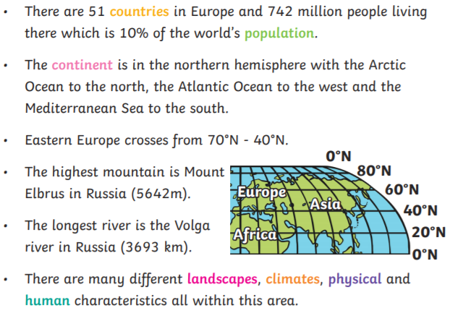 | Russia, the largest country in the world, occupies one-tenth of all the land on Earth. It spans 11 time zones across two continents (Europe and Asia) and has coasts on three oceans (the Atlantic, Pacific, and Arctic).  The Russian landscape varies from desert to frozen coastline, tall mountains to giant marshes. Much of Russia is made up of rolling, treeless plains called steppes. Siberia, which occupies three-quarters of Russia, is dominated by sprawling pine forests called taigas.  Russia has about 100,000 rivers, including some of the longest and most powerful in the world. It also has many lakes, including Europe's two largest: Ladoga and Onega. Lake Baikal in Siberia contains more water than any other lake on Earth.
