Thursday 11th February
RE – To begin to understand that God made a covenant (promise) with Abraham (Genesis 17) and that this is still important to Jews today.
Activity 1 – Look at the power point and then draw your own special picture to show God’s promise to Abraham. You can make your picture as colourful as you like and add collage too if you would like to!
God made a promise to Abraham. (Genesis 17)
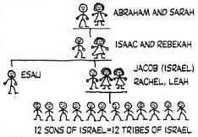
God said “Go to a new land and I will give you a family so big they will be like all the stars in the sky.”
Abraham and Sarah did as God said and God kept his promise and they had a baby son called Isaac. (look at the family tree beginning with Abraham and Sarah)
